# Visoka škola strukovnih studija za informacione I telekomunikacione tehnologije

GAMEHUT

<https://adamnik101.github.io/gamehut/>

Smer : Internet tehnologije

Modul: WEB programiranje

Predmet: WEB programiranje 2

Student: Adam Nikolić 101/19

# Sadržaj

Visoka škola strukovnih studija za informacione I telekomunikacione tehnologije 1

https://adamnik101.github.io/gamehut/ 1

1 Sadržaj 2

2 Uvod 3

2.1 Korisćene tehnologije 3

2.2 Opis funkcionalnosti 3

3 Template 5

3.1 index.html 5

3.2 shop.html 8

3.3 contact.html 9

3.4 cart.html 10

4 Organizacija 11

4.1 Organizaciona šema 11

5 Kodovi 11

5.1 index.html 12

5.2 shop.html 17

5.3 contact.html 24

5.4 single.html 28

5.5 author.html 32

5.6 main_styles.css 36

5.7 responsive.css 65

# Uvod

## Korisćene tehnologije

Za izradu sajta korišćene su sledeće tehnologije:

* HTML 5
* CSS 3
* Bootstrap
* Javascript
* jQuery
* AJAX
* PHP Storm / Visual Studio Code
* Gimp
* Owl-carousel slider

## Opis funkcionalnosti

Sajt poseduje sledeće funkcionalnosti:

* Sajt je prilagođen za sve vrste uređaja
* Dinamičko učitavanje navigacije u header-u, meniju za manje rezolucije i u futeru
* Dinamičko učitavanje slajdera na početnoj stranici i njegovog sadržaja
* Dinamičko učitavanje proizvoda na početnoj strani i u prodavnici
* Dinamičko učitavanje podataka određenog proizvoda na zasebnoj stranici (single.html) pomoću slanja ’id’ određenog proizvoda u Local Storage i dohvatanje tog proizvoda na osnovu ’id’-a
* Dodavanje proizvoda u korpu i brisanje, pomoću Local Storage-a, ukoliko je proizvod već dodat, povećaće se samo količina tog proizvoda
* Dinamičko učitavanje unetih proizvoda u korpu na stranici ’cart.html’
* Pamćenje svakog unetog email-a za newsletter i proveravanje za sve unete email-ove da li su već uneti pomoću kolačića
* Dinamičko učitavanje filtera po određenim kategorijama u prodavnici iz JSON fajlova
* Sortiranje proizvoda po ceni i nazivu, opadajuće i rastuće
* Pretraživanje proizvoda po unetom stringu
* Filtriranje u rangu izabrane cene
* Filtriranje proizvoda uz primenu više filtera odjednom, kao i po jednom u zavisnosti šta korisnik izabere
* Menjanje broja prikazanih proizvoda po stranici u prodavnici
* Dinamičko učitavanje paginacije
* Dinamičko učitavanje proizvoda koji će uskoro biti u ponudi pri dnu nekih stranica
* Proveravanje unetih podataka pomoću regularnih izraza (newsletter i kontakt forma) i ispisivanje grešaka na osnovu unetih podataka ukoliko ne prođu regularni izraz ili ako podaci nisu uneti
* Pamćenje pomoću kolačića kada je korisnik poslednji put poslao poruku preko kontakt forme, tako da sledeću poruku može da pošalje sat vremena od trenutka slanja poruke (sprečava spam)
* Dinamičko ispisivanje određene poruke na osnovu toga sta korisnik uradi(doda proizvod u korpu, posalje poruku preko kontakt forme, unese email za newsletter i određene poruke ako korisnik pokuša ponovo da uradi isto to)
* Ispisivanje poruke korisniku kad prvi put uđe na sajt koja ga obaveštava da sajt koristi kolačiće

# Template

Korišćen je preuzet template sa <https://themewagon.com/themes/free-bootstrap-ecommerce-website-template/> uz modifikacije prilagođene mojim potrebama

## index.html

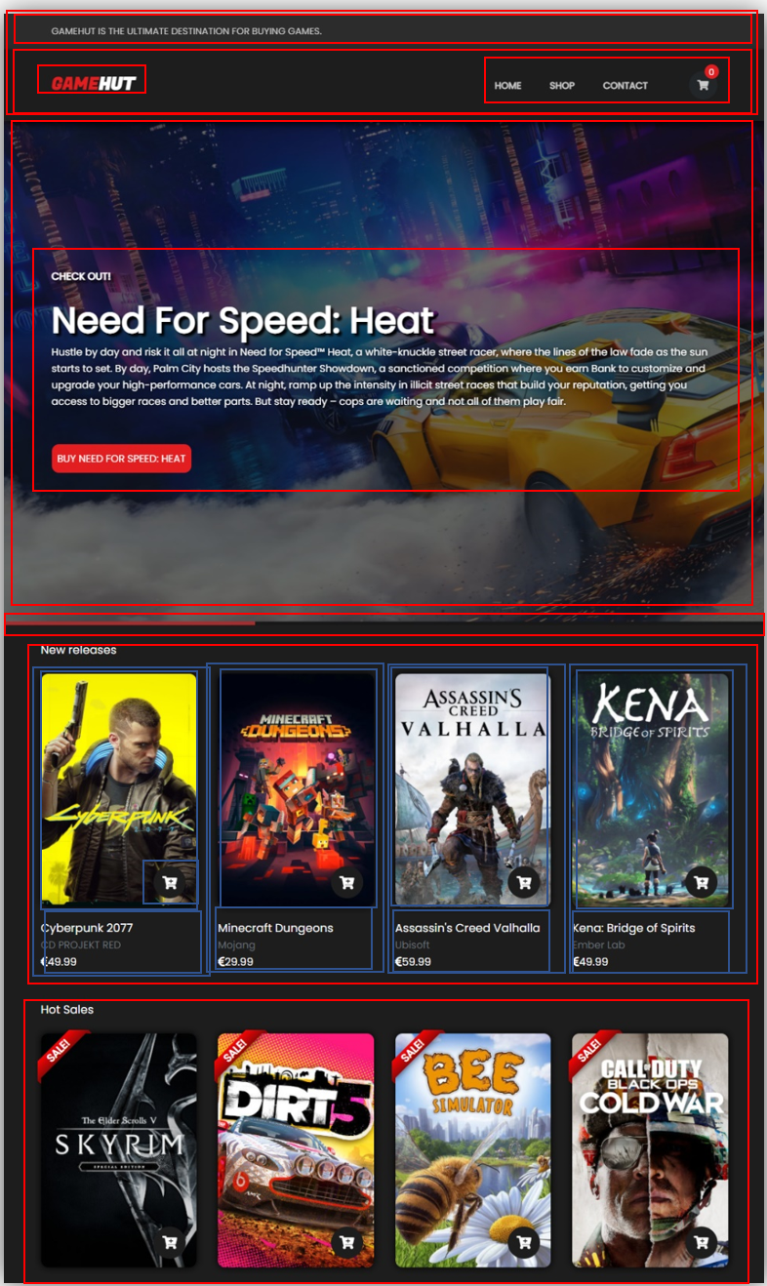

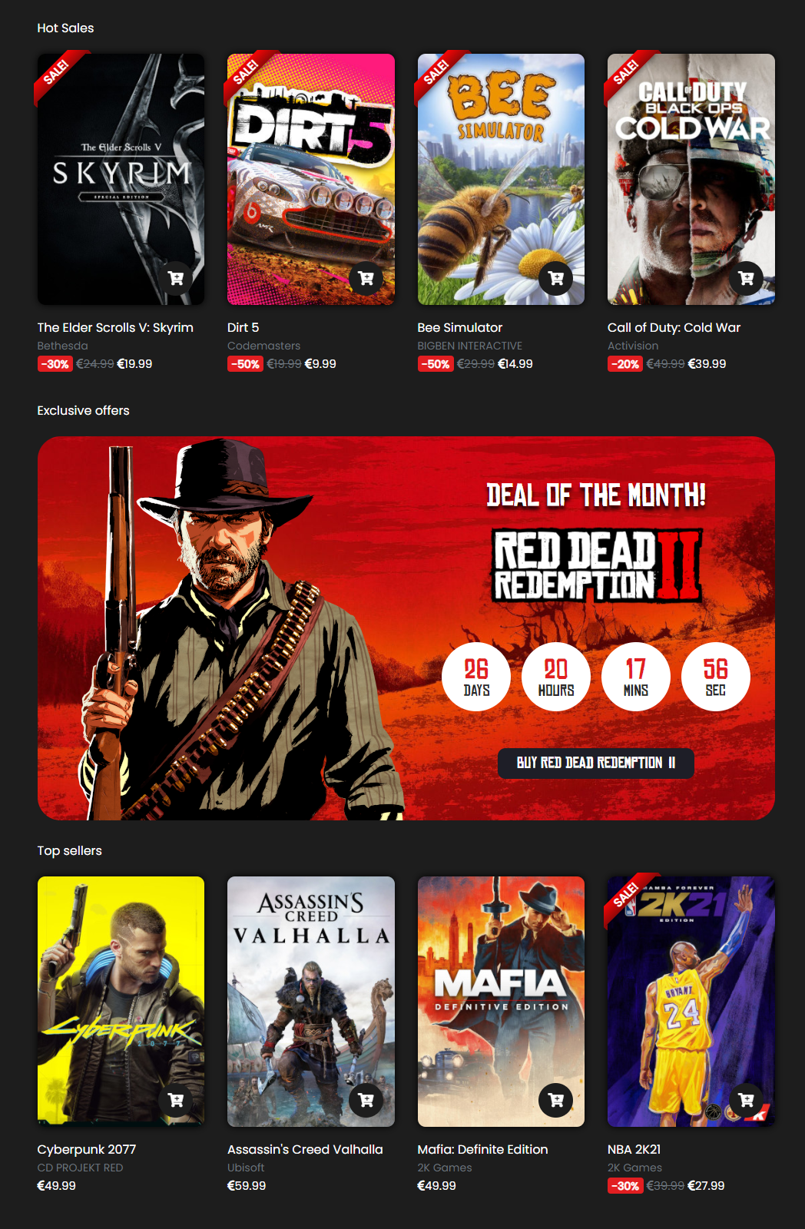

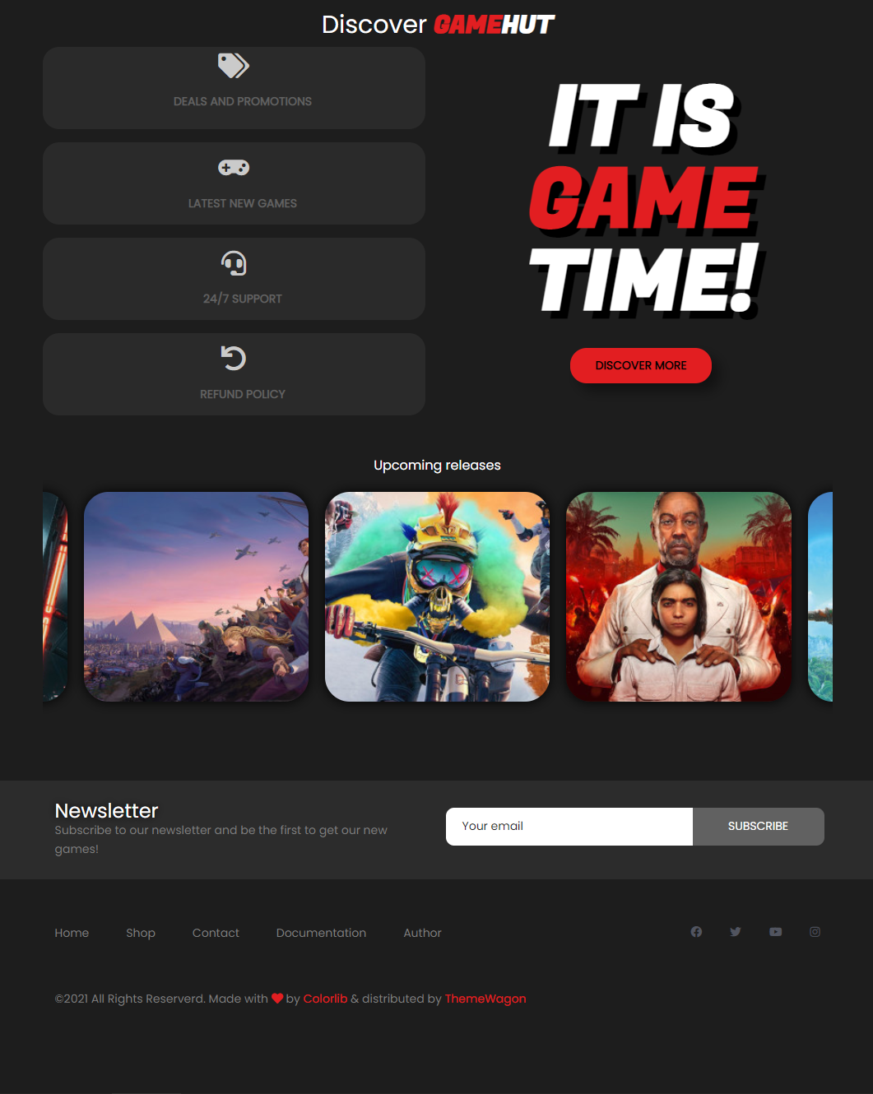

## shop.html

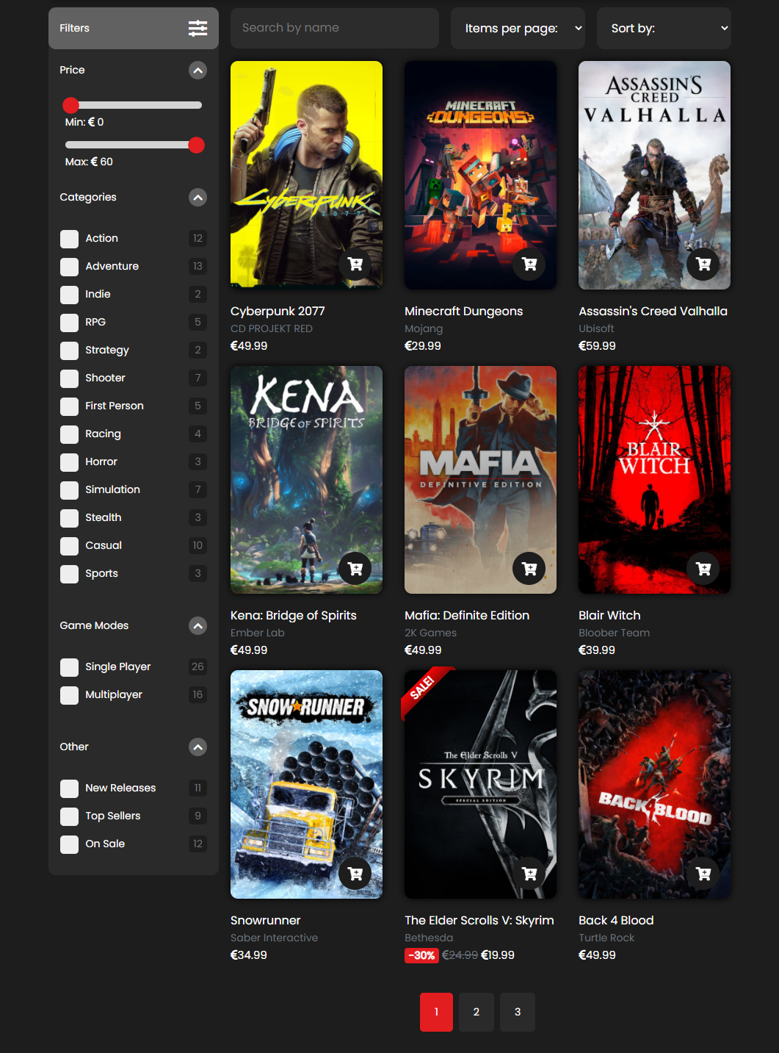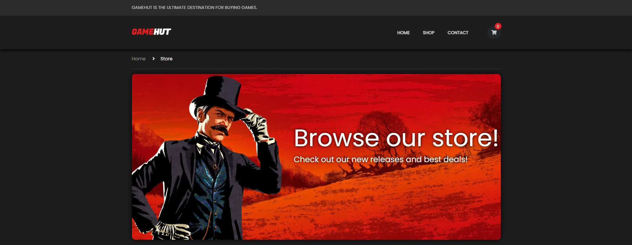

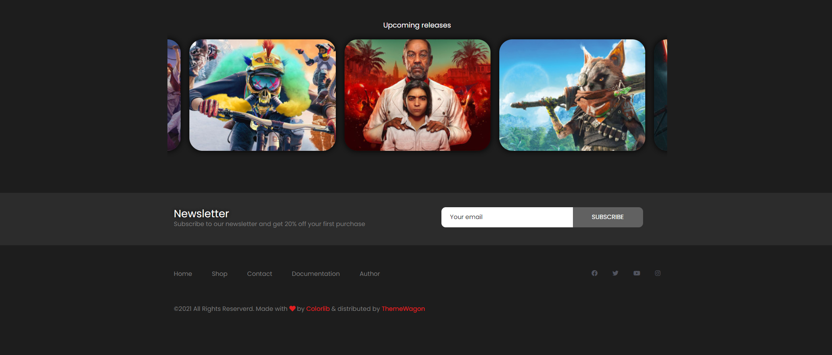

## contact.html

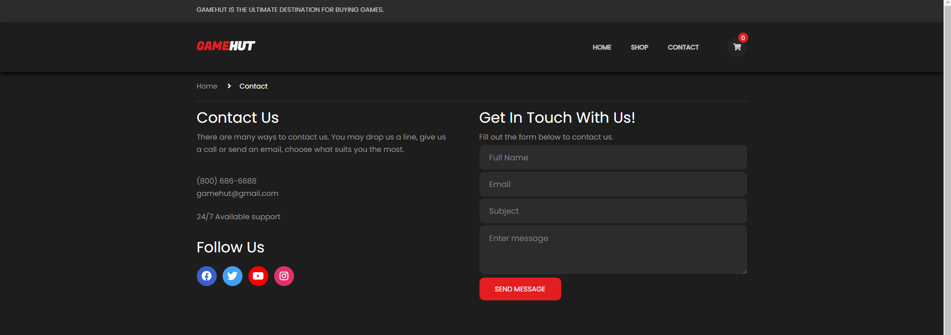



## cart.html

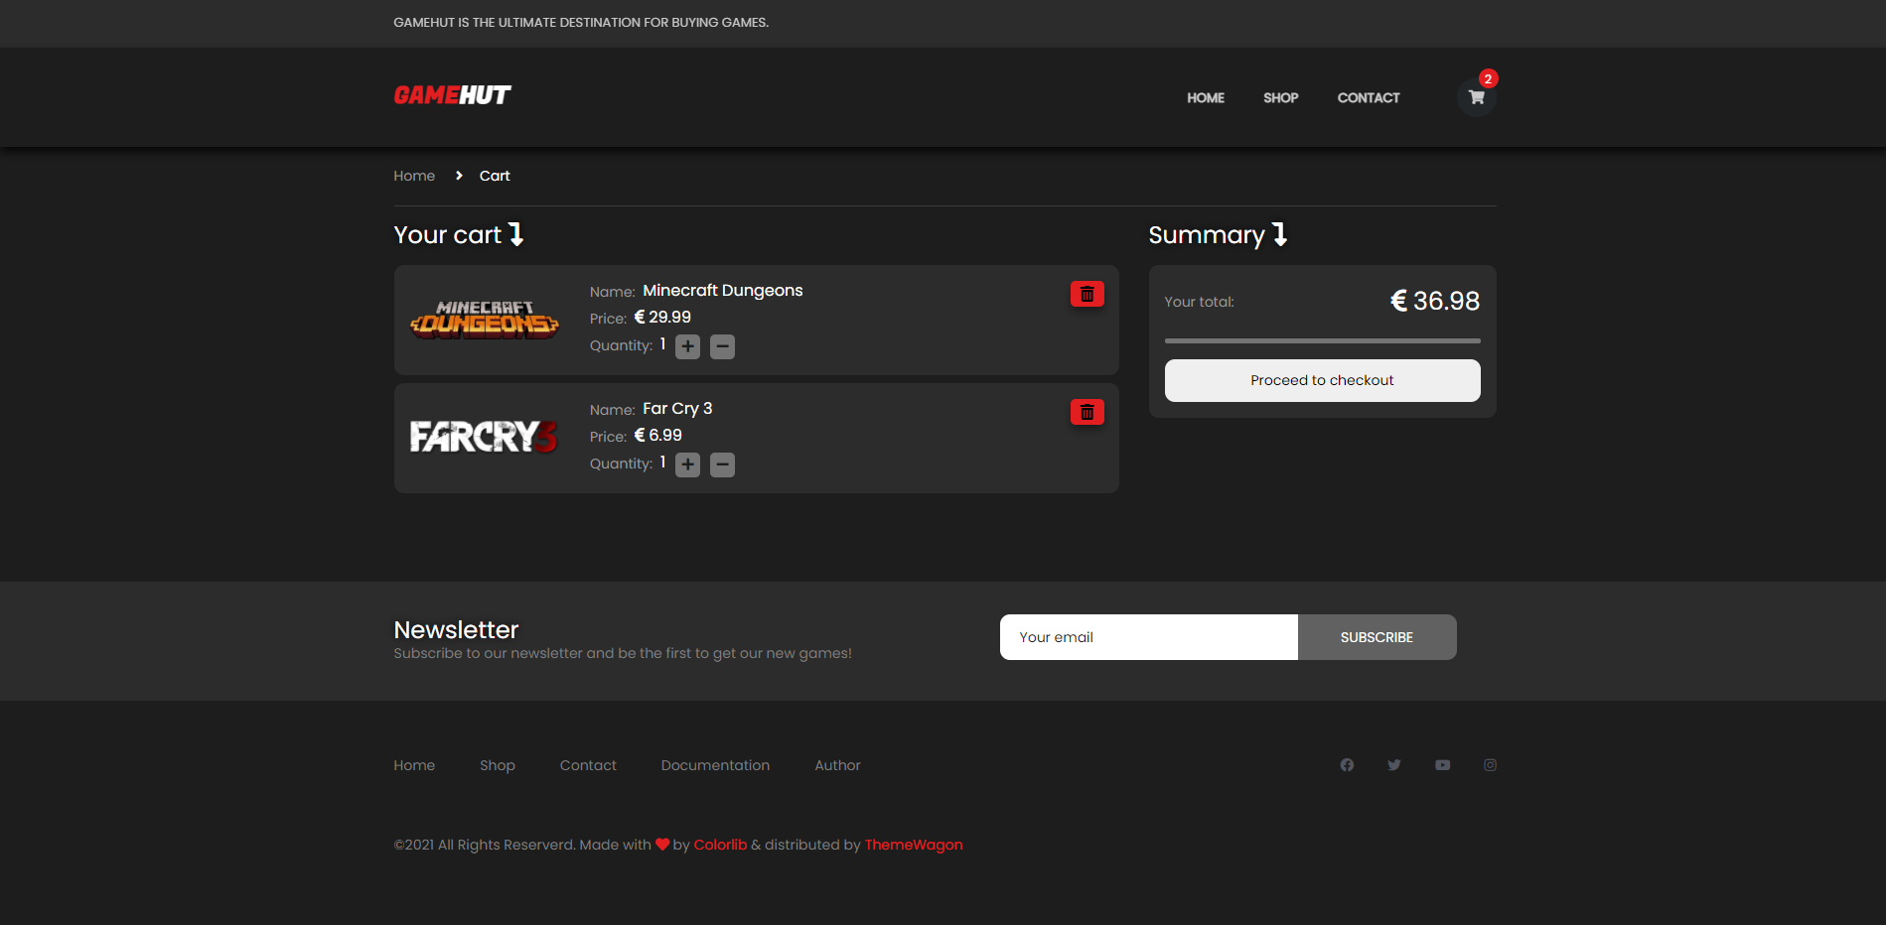

## author.html

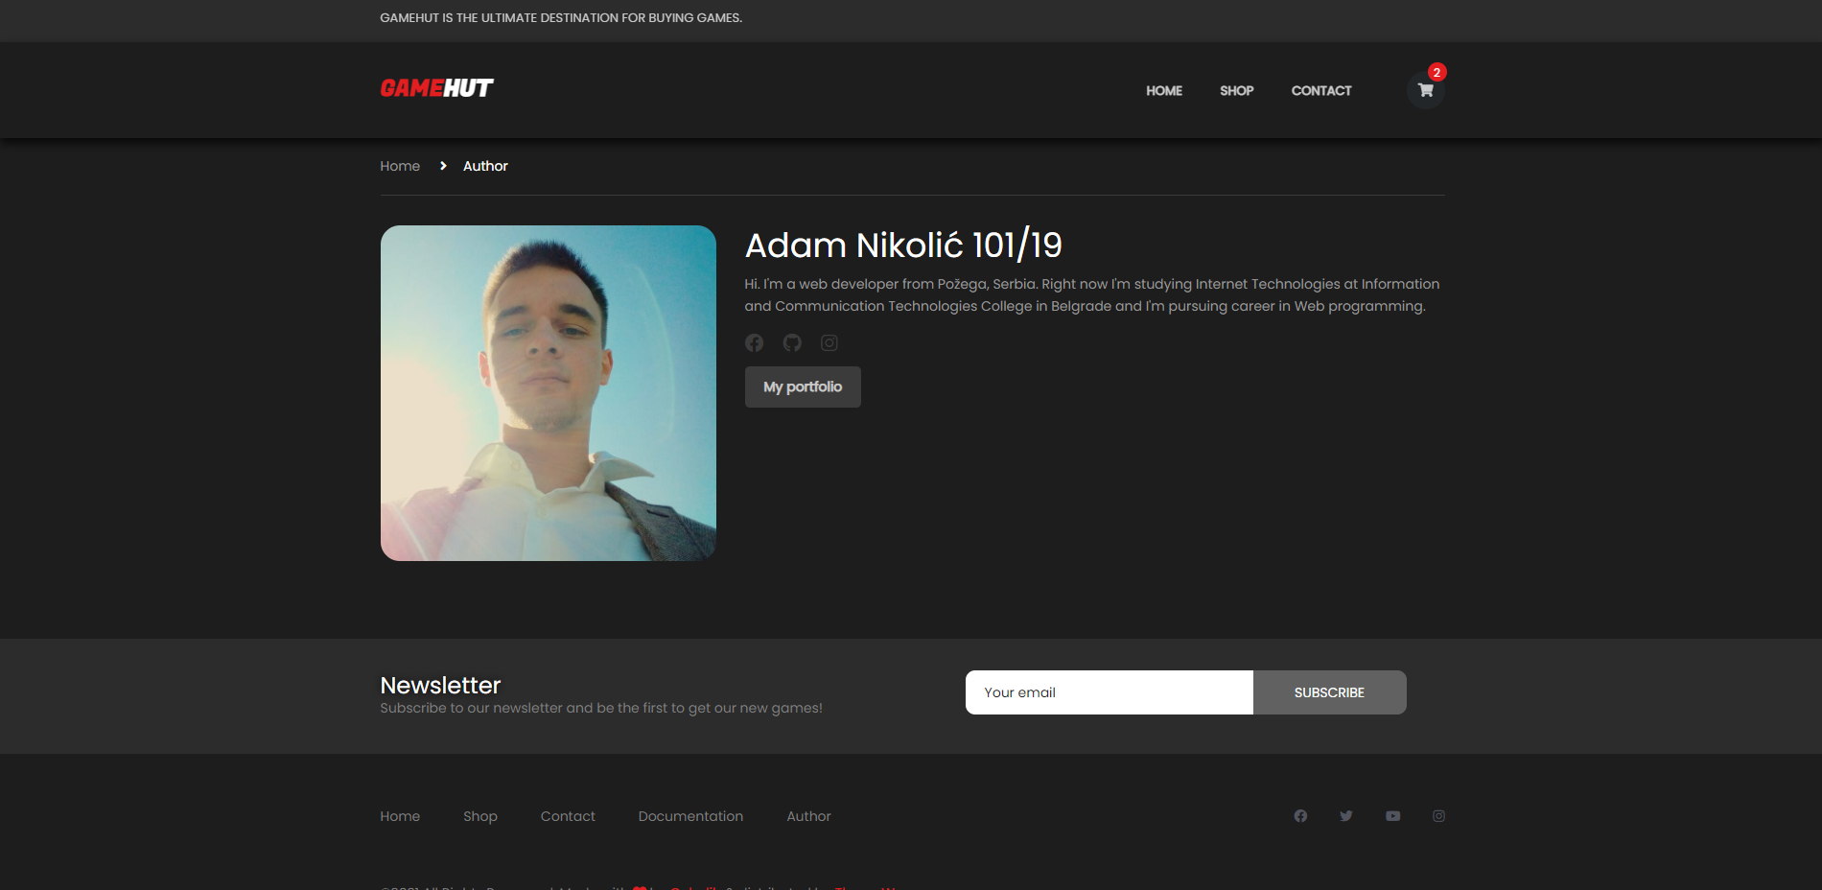

# Slike sekcija na stranicama i opisi funkcionalnosti

## navigacija

Glavna navigacija na velikim rezolucijama

* Navigacija se dinamički ispisuje dohvatanjem podataka iz JSON fajla (navigation.json)
* Ispisuje se na svakoj stranici sajta
* Fiksno je pozicionirana na vrhu stranice
* Tekst iznad navigacije se uklanja ukoliko korisnik skroluje na dole
* Takođe se ispisuje u footer-u i na manjim rezolucijama u sidenav-u
* Na manjim rezolucijama se pojavljuje ’hamburger’ i klikom na njega, korisniku se prikazuje sidenav sa navigacijom
* 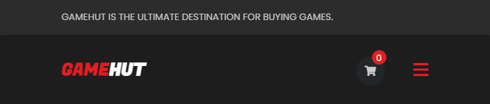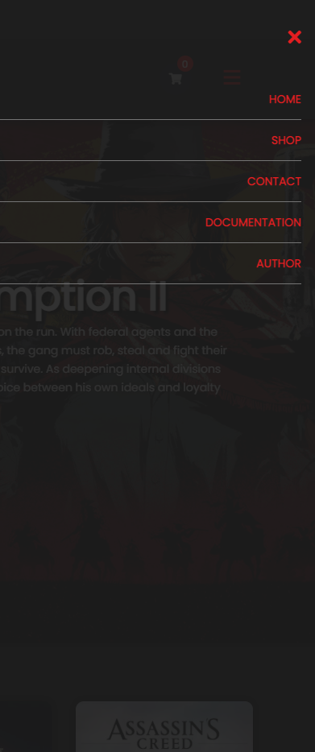Sidenav i footer sadrže dva dodatna linka ka dokumentaciji i autoru sajta

Navigacija u footer-u

Hamburger na manjim rezolucijama

Ispis navigacije na manjim rezolucijama

## Slajder

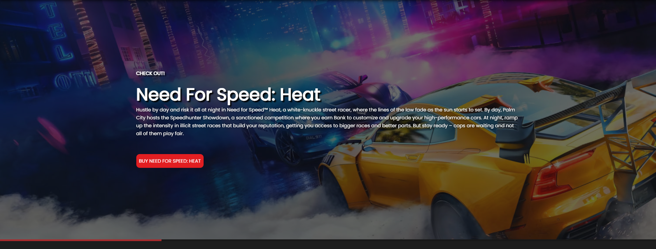

Slajder na početnoj stranici

* Slajder je inicijalizovan pomoću owl-carousel-a
* Korisniku je onemogućeno da skroluje levo-desno
* Slajder se dinamički učitava, prikazani podaci se dohvataju iz JSON fajla
* Slajder se na svakih 10 sekundi menja
* Odmah ispod slajdera se nalazi progress bar koji ukazuje korisniku koliko je preostalo vremena dok se slajder ne promeni
* Klikom na crveno dugme ’BUY ${naziv igrice}’, korisnik se usmerava na stranicu te igrice, pomoću Local Storage-a gde se prosleđuje ’id’ te igrice

## New releases

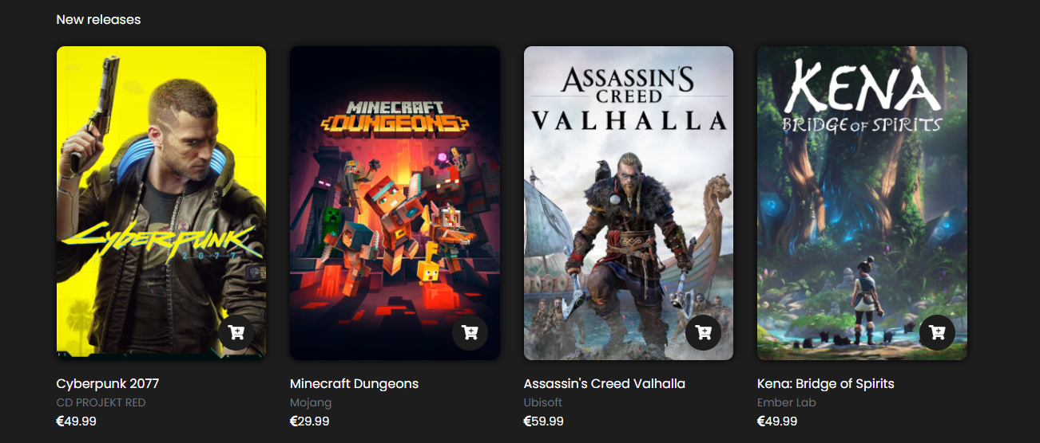

Prikaz igrica koje su skoro izasle

* Inicijalni prikaz sekcije ’New releases’ koja sadrži dinamičko ispisane igrice pomoću AJAX-a iz JSON fajla na osnovu toga da li su nove igrice

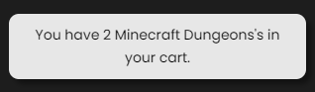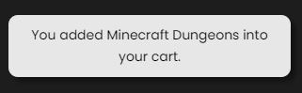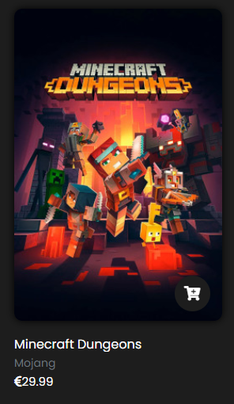Korisnik klikom na igricu se preusmerava na stranicu koja sadrži sve podatke o toj igrici(single.html). Prelaskom mišem preko ikonice sa korpom, prikazuje se tooltip sa porukom ’Add to cart’. Klikom na dugme sa ikonicom korpe, korisnik unosi u korpu tu igricu, unose se pomoću Local Storage-a. Ukoliko pre toga nije dodata u korpu, ispisuje mu se poruka je dodata u korpu, a ukoliko već postoji u korpi, ispisaće mu se poruka sa količinom te iste igrice u korpi, količina se povećava svakim klikom na dugme.

Poruka nakon drugog unosa u korpu

Poruka nakon prvog unosa u korpu

Prikaz jedne igrice

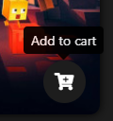

Prelazak mišem

## Hot sales

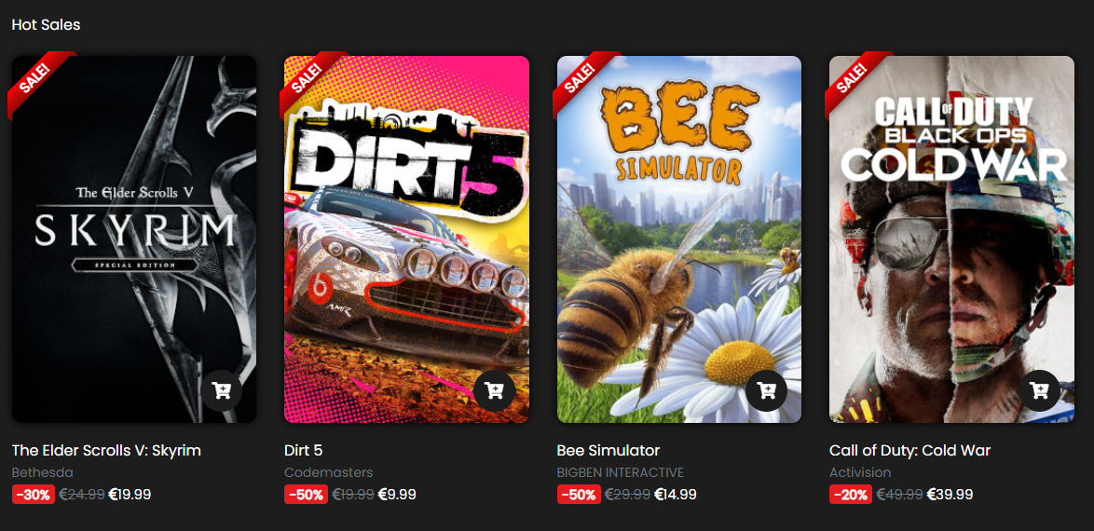

Prikaz 4 igrice koje su na popustu

* Inicijalni prikaz sekcije ’Hot Sales’ koja sadrži dinamičko ispisane igrice pomoću AJAX-a iz JSON fajla na osnovu toga da li su na popustu
* Ove igrice sadrže ribbon sa oznakom da su na popustu, koliki je popust i prethodnu cenu igrice

## Exclusive offer

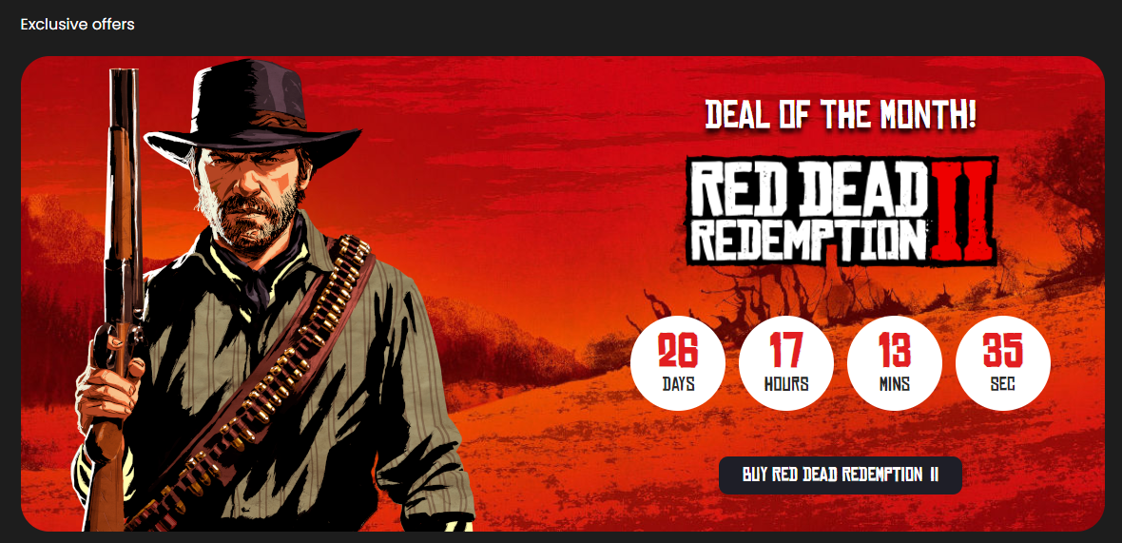

Sekcija sa prikazom istaknute igrice

* Ova sekcija sadrži tajmer do zadatog datuma, do kraja tekućeg meseca i ispisom logo-a istaknute igrice,nakon završetka tajmera se ispisuje poruka da će uskoro biti prikazana druga igrica, klikom na dugme ’BUY RED DEAD REDEMPTION II’ korisnik se usmerava na stranicu te igrice

## Best sellers

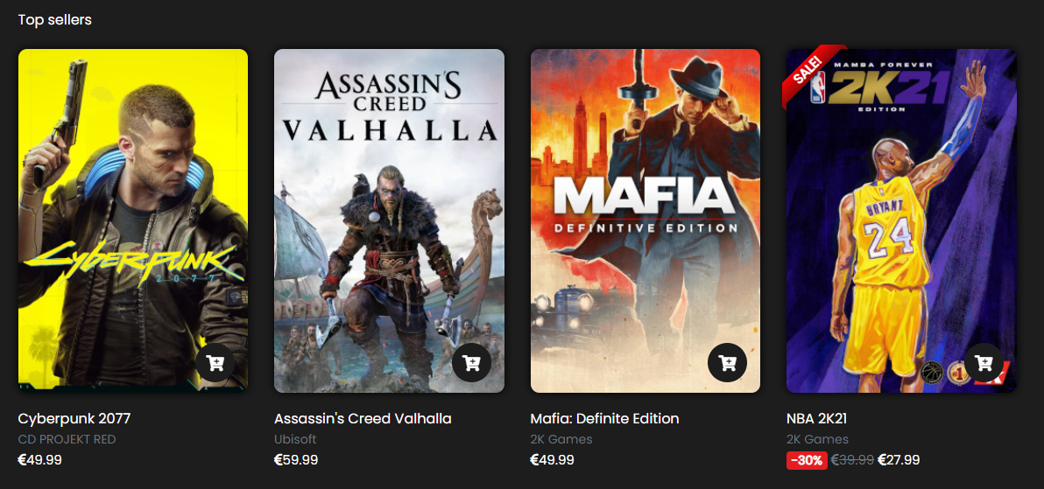

Prikaz 4 igrice koje su najprodavanije

* Inicijalni prikaz sekcije ’Best sellers’ koja sadrži dinamičko ispisane igrice pomoću AJAX-a iz JSON fajla na osnovu toga da li su najprodavanije

## Discover

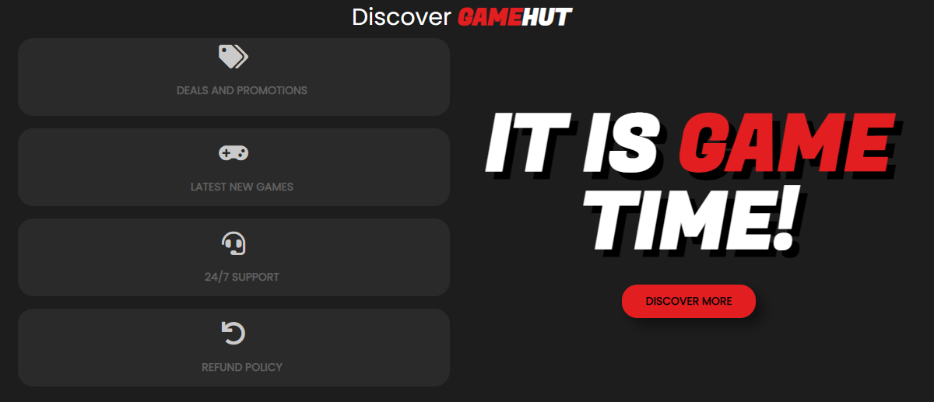

Sekcija o nekim informacijama

## Upcoming games

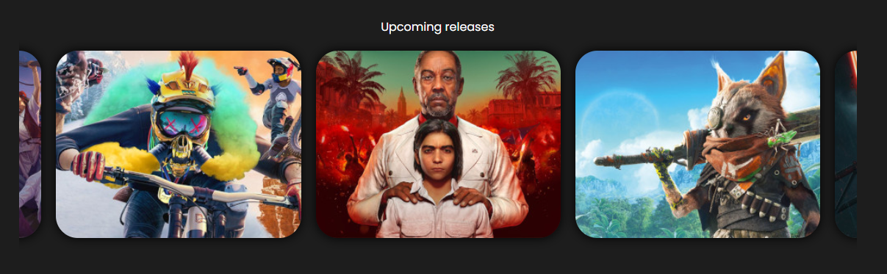

Sekcija sa igricama koje uskoro izlaze

* Igrice se dinamički ispisuju pomoću AJAX-a iz JSON fajla (comingSoon.json)
* Slajder se takodje dinamički prikazuje(owl-carousel)
* Prelaskom mišem preko bloka sa igricom, prikazuje se logo te igrice i datum kada izlazi
* Ova sekcija se nalazi na početnoj stranici i u prodavnici (index.html & shop.html)

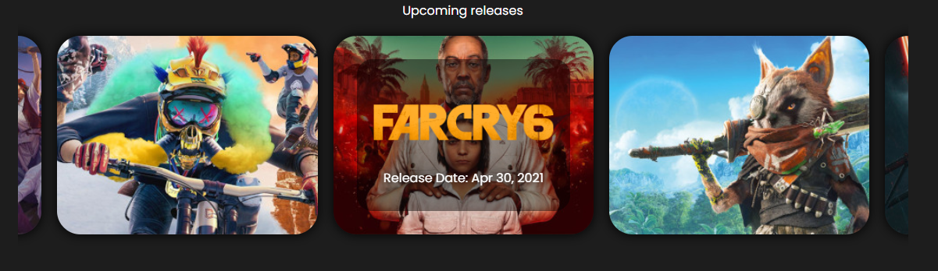

Prikaz prelaskom miša preko bloka sa igricom

## Newsletter



Newsletter forma

* Newsletter forma se sastoji od jednog tekstualnog polja namenjen za email i jednog dugmeta za slanje
* Provera vrednosti za uneto polje se proverava regularnim izrazom za email
* Ispisaće se greska ukoliko korisnik ne popuni ispravno email
* Ukoliko ispravno popuni polje, prikazaće mu se poruka da se uspešno prijavio za newsletter
* Ukoliko ponovo unese isti email, proverava se da li već postoji taj email u kolačićima, ako postoji onda mu se prikazuje poruka da je već prijavljen
* 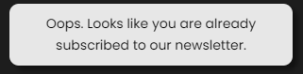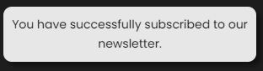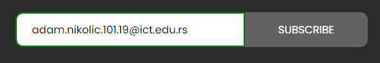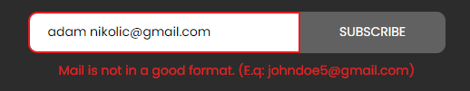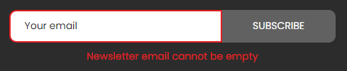Svaki uneti email se čuva posebno u kolačić za sebe i u trajanju je od 6 meseci

Ukoliko provera vrati da email već postoji u kolačićima

Ukoliko provera vrati da nema taj email u kolačićima

Ukoliko unese ispravno email

Ukoliko ne unese ispravno email

Ukoliko pokuša da pošalje, a da pre toga ništa nije uneto u polje

## Footer

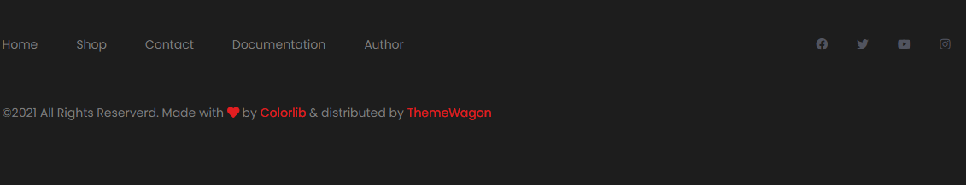

Footer

* Footer koji dinamički učitava linkove za navigaciju pomoću AJAX-a iz JSON fajla
* Footer se nalazi na svakoj stranici

# Organizacija

## sitemap.xml

<?xml version="1.0" encoding="UTF-8"?>  
<urlset xmlns="http://www.sitemaps.org/schemas/sitemap/0.9">  
 <url>  
 <loc>https://adamnik101.github.io/gamehut/index.html</loc>  
 <lastmod>2021-03-05</lastmod>  
 <changefreq>daily</changefreq>  
 <priority>1</priority>  
 </url>  
 <url>  
 <loc>https://adamnik101.github.io/gamehut/shop.html</loc>  
 <lastmod>2021-03-05</lastmod>  
 <changefreq>daily</changefreq>  
 <priority>0.9</priority>  
 </url>  
 <url>  
 <loc>https://adamnik101.github.io/gamehut/contact.html</loc>  
 <lastmod>2021-03-05</lastmod>  
 <changefreq>monthly</changefreq>  
 <priority>0.6</priority>  
 </url>  
 <url>  
 <loc>https://adamnik101.github.io/gamehut/author.html</loc>  
 <lastmod>2021-03-05</lastmod>  
 <changefreq>monthly</changefreq>  
 <priority>0.4</priority>  
 </url>  
</urlset>

## Organizaciona šema

# Kodovi

## index.html

<!DOCTYPE html>  
<html lang="en">  
<head>  
 <title>Game Hut - PC Games</title>  
 <meta charset="utf-8">  
 <meta http-equiv="X-UA-Compatible" content="IE=edge">  
 <meta name="description" content="Colo Shop Template">  
 <meta name="viewport" content="width=device-width, initial-scale=1">  
 <link rel="shortcut icon" href="images/favicon.png" type="image/x-icon">  
 <link rel="stylesheet" href="https://use.fontawesome.com/releases/v5.15.1/css/all.css" integrity="sha384-vp86vTRFVJgpjF9jiIGPEEqYqlDwgyBgEF109VFjmqGmIY/Y4HV4d3Gp2irVfcrp" crossorigin="anonymous">  
 <link rel="stylesheet" href="https://cdn.jsdelivr.net/npm/bootstrap@4.6.0/dist/css/bootstrap.min.css" integrity="sha384-B0vP5xmATw1+K9KRQjQERJvTumQW0nPEzvF6L/Z6nronJ3oUOFUFpCjEUQouq2+l" crossorigin="anonymous">  
 <link rel="stylesheet" type="text/css" href="owlcarousel/owl.carousel.min.css"/>  
 <link rel="stylesheet" type="text/css" href="styles/main_styles.css">  
 <link rel="stylesheet" type="text/css" href="styles/responsive.css">  
</head>  
  
<body>  
 <div class="loader-flex-fix">  
 <div class="loader-wrapper">  
 <div class="loader"></div>  
 </div>  
 </div>  
  
<div class="super_container">  
  
 <!-- Header -->  
  
 <header class="header trans_300">  
  
 <!-- Top Navigation -->  
  
 <div class="top_nav">  
 <div class="container">  
 <div class="row">  
 <div class="col-md-6">  
 <div class="top_nav_left">Gamehut is the ultimate destination for buying games.</div>  
 </div>  
 <div class="col-md-6 text-right">  
   
 </div>  
 </div>  
 </div>  
 </div>  
  
 <!-- Main Navigation -->  
  
 <div class="main_nav_container">  
 <div class="container">  
 <div class="row">  
 <div class="col-lg-12 text-right">  
 <div class="logo_container">  
 <a href="index.html">game<span>hut</span></a>  
 </div>  
 <nav class="navbar">  
 <ul class="navbar_menu">  
  
 </ul>  
 <ul class="navbar_user">  
   
 <li class="checkout">  
 <a href="cart.html">  
 <i class="fa fa-shopping-cart" aria-hidden="true"></i>  
 <span id="checkout_items" class="checkout_items"></span>  
 </a>  
 </li>  
 </ul>  
 <div class="hamburger_container">  
 <i class="fa fa-bars" aria-hidden="true"></i>  
 </div>  
 </nav>  
 </div>  
 </div>  
 </div>  
 </div>  
  
 </header>  
  
 <div class="fs_menu_overlay"></div>  
 <div class="hamburger_menu">  
 <div class="hamburger_close"><i class="fa fa-times" aria-hidden="true"></i></div>  
 <div class="hamburger_menu_content text-right">  
 <ul class="menu_top_nav">  
  
 </ul>  
 </div>  
 </div>  
  
 <!-- Slider -->  
  
 <div class="main_slider">  
 <div id="transparent"></div>  
 <div id="slider">  
  
 </div>  
  
 <div class="progress">  
 <div id="progressBar"></div>  
 </div>  
 </div>  
  
  
 <div class="banner">  
 <div class="container">  
 <div class="row d-flex justify-content-between flex-column" id="new">  
 <div class="col-12 pl-0 pb-3"><h5>New releases</h5></div>  
 <div class="col-12 p-0">  
 <div id="newReleases">  
  
 </div>  
 </div>  
   
 </div>  
 </div>  
 </div>  
 <div class="banner">  
 <div class="container">  
 <div class="row d-flex justify-content-between flex-column">  
 <div class="col-12 pl-0 pb-3">  
 <h5>Hot Sales</h5>  
 </div>  
 <div class="col-12 p-0">  
 <div id="hotSales"></div>  
 </div>  
   
 </div>  
 </div>  
 </div>  
 <div class="new_arrivals mt-4 pl-3 pr-3">  
 <div class="container">  
 <div class="row">  
 <div class="col-12 pl-0 pb-3">  
 <h5>Exclusive offers </h5>  
 </div>  
 </div>  
 <div class="row align-items-center" id="box">  
 <div class="deal_ofthe_week">  
 <div class="row">  
 <div class="col-lg-6">  
 <div class="deal_ofthe_week_img">  
 <img src="images/deal_week_guy.png" class="img-fluid" alt="guy1880">  
 </div>  
 </div>  
 <div class="col-lg-6 text-right deal_ofthe_week_col">  
 <div class="deal_ofthe_week_content d-flex flex-column align-items-center justify-content-center">  
 <div class="section_title d-flex flex-column align-items-center">  
 <h2 class="mb-3">Deal of the month!</h2>  
 <img src="images/rdr2_logo.png" alt="logo">  
 </div>  
 <ul class="timer mt-5">  
 <li class="d-inline-flex flex-column justify-content-center align-items-center">  
 <div id="day" class="timer_num"></div>  
 <div class="timer_unit">Days</div>  
 </li>  
 <li class="d-inline-flex flex-column justify-content-center align-items-center">  
 <div id="hour" class="timer_num"></div>  
 <div class="timer_unit">Hours</div>  
 </li>  
 <li class="d-inline-flex flex-column justify-content-center align-items-center">  
 <div id="minute" class="timer_num"></div>  
 <div class="timer_unit">Mins</div>  
 </li>  
 <li class="d-inline-flex flex-column justify-content-center align-items-center">  
 <div id="second" class="timer_num"></div>  
 <div class="timer_unit">Sec</div>  
 </li>  
 </ul>  
 <a href="shop.html" class="mt-5"><div class="red_button deal_ofthe_week_button d-flex justify-content-center align-items-center flex-row">Buy Red Dead Redemption <span class="pl-2">II</span> </div></a>  
 </div>  
 </div>  
 </div>  
 </div>  
 </div>  
 </div>  
 </div>  
 <div class="banner">  
 <div class="container">  
 <div class="row d-flex justify-content-between flex-column">  
 <div class="col-12 pl-0 pb-3">  
 <h5>Top sellers</h5>  
 </div>  
 <div class="col-12 p-0">  
 <div id="topSellers"></div>  
 </div>  
   
 </div>  
 </div>  
 </div>  
 <div class="benefit">  
 <div class="container p-3 p-sm-0">  
 <div class="row">  
 <div class="col">  
 <h1 class="text-center colorH1Span">Discover <span class="text-uppercase font-weight-bold">game</span><span class="text-uppercase font-weight-bold">Hut</span></h1>  
 </div>  
 </div>  
 <div class="row row-cols-2">  
 <div class="col-12 col-md-6">  
 <div class="row row-cols-1">  
 <div class="col benefit_col mb-3">  
 <div class="benefit-clip"></div>  
 <div class="benefit_item d-flex flex-column align-items-center justify-content-center">  
 <div class="benefit_icon pb-3"><i class="fas fa-tags"></i></div>  
 <div class="benefit_content">  
 <h6>Deals and promotions</h6>  
 <p></p>  
 </div>  
 </div>  
 </div>  
 <div class="col benefit_col mb-3">  
 <div class="benefit-clip"></div>  
 <div class="benefit_item d-flex flex-column align-items-center justify-content-center">  
 <div class="benefit_icon pb-3"><i class="fas fa-gamepad"></i></div>  
 <div class="benefit_content">  
 <h6>Latest new games</h6>  
 </div>  
 </div>  
 </div>  
 <div class="col benefit_col mb-3">  
 <div class="benefit-clip"></div>  
 <div class="benefit_item d-flex flex-column align-items-center justify-content-center">  
 <div class="benefit_icon pb-3"><i class="fas fa-headset"></i></div>  
 <div class="benefit_content">  
 <h6>24/7 support</h6>  
 </div>  
 </div>  
 </div>  
 <div class="col benefit_col">  
 <div class="benefit-clip"></div>  
 <div class="benefit_item d-flex flex-column align-items-center justify-content-center">  
 <div class="benefit_icon pb-3"><i class="fas fa-undo"></i></div>  
 <div class="benefit_content">  
 <h6>Refund policy</h6>  
 </div>  
 </div>  
 </div>  
 </div>  
 </div>  
 <div class="col-12 col-md-6 discover d-flex justify-content-center align-items-center flex-column-reverse">  
 <button type="button" id="btnDiscover">DISCOVER MORE</button>  
 <h1 class="game mt-5 mt-md-0">IT IS <span>GAME</span><span></span> TIME!</h1>  
 </div>  
   
 </div>  
 </div>  
 </div>  
  
 <!-- Upcoming -->  
  
 <div class="upcoming">  
 <div class="container">  
 <div class="row">  
 <div class="col text-center">  
 <div class="section_title">  
 <h5>Upcoming releases</h5>  
 </div>  
 </div>  
 </div>  
 <div class="row coming-soon">  
 </div>  
 </div>  
 </div>  
  
 <!-- Newsletter -->  
  
 <div class="newsletter">  
 <div class="container">  
 <div class="row">  
 <div class="col-lg-6">  
 <div class="newsletter_text d-flex flex-column justify-content-center align-items-lg-start align-items-md-center text-center text-lg-left">  
 <h4>Newsletter</h4>  
 <p>Subscribe to our newsletter and be the first to get our new games!</p>  
 </div>  
 </div>  
 <div class="col-lg-6 d-flex justify-content-center align-items-center">  
 <form method="POST" id="newsletter_form" class="d-flex justify-content-center align-items-center flex-column">  
 <div class="newsletter_form d-flex flex-md-row flex-column flex-xs-column align-items-center justify-content-lg-end justify-content-center">  
 <input id="newsletter_email" type="email" placeholder="Your email">  
 <input id="newsletter_submit" type="submit" class="newsletter_submit_btn trans_300" value="Subscribe">  
 </div>  
 <span class="err newsletterErr text-center pb-2 pb-lg-0 pt-lg-2 pt-0"></span>  
 </form>  
 </div>  
 </div>  
 </div>  
 </div>  
  
 <!-- Footer -->  
  
 <footer class="footer">  
 <div class="container">  
 <div class="row">  
 <div class="col-lg-7">  
 <div class="footer_nav_container d-flex flex-sm-row flex-column align-items-center justify-content-lg-start justify-content-center text-center">  
 <ul class="footer_nav">  
  
 </ul>  
 </div>  
 </div>  
 <div class="col-lg-5">  
 <div class="footer_social d-flex flex-row align-items-center justify-content-lg-end justify-content-center">  
 <ul>  
 <li><a href="https://www.facebook.com"><i class="fab fa-facebook"></i></a></li>  
 <li><a href="https://www.twitter.com"><i class="fab fa-twitter"></i></a></li>  
 <li><a href="https://www.youtube.com"><i class="fab fa-youtube"></i></a></li>  
 <li><a href="https://www.instagram.com"><i class="fab fa-instagram"></i></a></li>  
 </ul>  
 </div>  
 </div>  
 </div>  
 <div class="row">  
 <div class="col-lg-12">  
 <div class="footer_nav_container">  
 <div class="cr">&copy;2021 All Rights Reserverd. Made with <i class="fas fa-heart"></i> by <a href="#">Colorlib</a> &amp; distributed by <a href="https://themewagon.com">ThemeWagon</a></div>  
 </div>  
 </div>  
 </div>  
 </div>  
 </footer>  
 <div id="cookie-wrapper">  
 <div id="cookie-notice" class="p-2 d-flex justify-content-around align-items-center flex-column flex-lg-row">  
 <p class="text-center m-0 mb-3 mb-lg-0">We use cookies to provide you with a better experience. By continuing to use our site you accept our <a href="#!">cookie policy.</a></p>  
 <button type="button" id="cookie-accept">I understand</button>  
 </div>  
 </div>  
</div>  
  
<script src="https://code.jquery.com/jquery-3.5.1.min.js" integrity="sha256-9/aliU8dGd2tb6OSsuzixeV4y/faTqgFtohetphbbj0=" crossorigin="anonymous"></script>  
<script src="https://cdn.jsdelivr.net/npm/bootstrap@4.6.0/dist/js/bootstrap.bundle.min.js" integrity="sha384-Piv4xVNRyMGpqkS2by6br4gNJ7DXjqk09RmUpJ8jgGtD7zP9yug3goQfGII0yAns" crossorigin="anonymous"></script>  
<script type="text/javascript" src="owlcarousel/owl.carousel.min.js"></script>  
<script src="js/custom.js"></script>  
</body>  
  
</html>

## shop.html

<!DOCTYPE html>  
<html lang="en">  
<head>  
<title>Game Hut - Store</title>  
<meta charset="utf-8">  
<meta http-equiv="X-UA-Compatible" content="IE=edge">  
<meta name="description" content="Colo Shop Template">  
<meta name="viewport" content="width=device-width, initial-scale=1">  
<link rel="shortcut icon" href="images/favicon.png" type="image/x-icon">  
<link rel="stylesheet" href="https://cdn.jsdelivr.net/npm/bootstrap@4.6.0/dist/css/bootstrap.min.css" integrity="sha384-B0vP5xmATw1+K9KRQjQERJvTumQW0nPEzvF6L/Z6nronJ3oUOFUFpCjEUQouq2+l" crossorigin="anonymous">  
<link rel="stylesheet" href="https://use.fontawesome.com/releases/v5.15.1/css/all.css" integrity="sha384-vp86vTRFVJgpjF9jiIGPEEqYqlDwgyBgEF109VFjmqGmIY/Y4HV4d3Gp2irVfcrp" crossorigin="anonymous">  
<link rel="stylesheet" type="text/css" href="owlcarousel/owl.carousel.min.css"/>  
<link rel="stylesheet" type="text/css" href="styles/main_styles.css">  
<link rel="stylesheet" type="text/css" href="styles/responsive.css">  
</head>  
  
<body>  
<div class="loader-flex-fix">  
 <div class="loader-wrapper">  
 <div class="loader"></div>  
 </div>  
</div>  
<div class="super_container">  
  
 <!-- Header -->  
  
 <header class="header trans_300">  
  
 <!-- Top Navigation -->  
  
 <div class="top_nav">  
 <div class="container">  
 <div class="row">  
 <div class="col-md-6">  
 <div class="top_nav_left">Gamehut is the ultimate destination for buying games.</div>  
 </div>  
 <div class="col-md-6 text-right">  
 <div class="top_nav_right">  
 <ul class="top_nav_menu">  
  
   
 </ul>  
 </div>  
 </div>  
 </div>  
 </div>  
 </div>  
  
 <!-- Main Navigation -->  
  
 <div class="main_nav_container">  
 <div class="container">  
 <div class="row">  
 <div class="col-lg-12 text-right">  
 <div class="logo_container">  
 <a href="#">game<span>hut</span></a>  
 </div>  
 <nav class="navbar">  
 <ul class="navbar_menu">  
  
 </ul>  
 <ul class="navbar_user">  
 <li class="checkout">  
 <a href="cart.html">  
 <i class="fa fa-shopping-cart" aria-hidden="true"></i>  
 <span id="checkout_items" class="checkout_items"></span>  
 </a>  
 </li>  
 </ul>  
 <div class="hamburger_container">  
 <i class="fa fa-bars" aria-hidden="true"></i>  
 </div>  
 </nav>  
 </div>  
 </div>  
 </div>  
 </div>  
  
 </header>  
  
 <div class="fs_menu_overlay"></div>  
  
 <!-- Hamburger Menu -->  
  
 <div class="hamburger_menu">  
 <div class="hamburger_close"><i class="fa fa-times" aria-hidden="true"></i></div>  
 <div class="hamburger_menu_content text-right">  
 <ul class="menu_top_nav">  
  
 </ul>  
 </div>  
 </div>  
  
 <div class="container breadcrumbs_container">  
 <div class="row">  
 <div class="col">  
 <!-- Breadcrumbs -->  
 <div class="breadcrumbs d-flex flex-row align-items-center">  
 <ul>  
 <li><a href="index.html">Home</a></li>  
 <li class="active"><a href="shop.html"><i class="fa fa-angle-right" aria-hidden="true"></i>Store</a></li>  
 </ul>  
 </div>  
  
 </div>  
 </div>  
 </div>  
 <div class="container">  
 <div class="row m-0">  
 <div class="col-12" id="store-banner">  
 <img src="images/store_banner.png" class="img-fluid" alt="guy_with_hat_tipping">  
 <div>  
 <h1>Browse our store!</h1>  
 <h4>Check out our new releases and best deals!</h4>  
 </div>  
 </div>  
 </div>  
 </div>  
 <div class="container">  
 <div class="row m-0">  
 <div class="col-12 col-lg-3 p-0 mt-0 mt-lg-3" id="filter-wrapper">  
 <div id="filter">  
 <span id="filterBg" class="d-flex justify-content-between align-items-center p-3">  
 <span>Filters</span>  
 <i class="fas fa-sliders-h"></i>  
 </span>   
 <div id="price-container" class="d-block">  
 <span class="d-flex justify-content-between align-items-center p-3 hoverFilter" id="priceToggle">  
 <span>Price</span>  
 <span class="circ d-flex justify-content-center align-items-center"><i class="fas fa-chevron-up"></i></span>  
 </span>  
 <div class="pt-2" id="priceRange">  
 <div class="slidecontainer mx-auto">  
 <form action="" method="GET">  
 <input type="range" min="0" max="60" value="0" class="slider" id="priceFrom">  
 <label for="priceFrom" id="labelMin">Min: <i class="fas fa-euro-sign"></i> <output id="from">0</output></label>  
 <input type="range" min="0" max="60" value="60" class="slider" id="priceTo">  
 <label for="priceTo" id="labelMax">Max: <i class="fas fa-euro-sign"></i> <output id="to">60</output></label>  
 </form>  
 </div>  
 </div>  
   
 </div>  
 <div id="categories-container" class="d-block">  
 <span id="filterCat" class="d-flex justify-content-between align-items-center p-3 hoverFilter">  
 <span>Categories</span>  
 <span class="circ d-flex justify-content-center align-items-center"><i class="fas fa-chevron-up"></i></span>  
 </span>  
 <ul class="whiteChb" id="categoryChb">  
   
 </ul>  
 </div>  
 <div id="more-filters-container" class="d-block">  
 <span id="more-filters" class="d-flex justify-content-between align-items-center p-3 hoverFilter">  
 <span>Game Modes</span>  
 <span class="circ d-flex justify-content-center align-items-center"><i class="fas fa-chevron-up"></i></span>  
 </span>  
 <ul id="mode" class="whiteChb">  
   
 </ul>  
 </div>  
 <div id="other-filter-container" class="d-block">  
 <span id="filter-other" class="d-flex justify-content-between align-items-center p-3 hoverFilter">  
 <span>Other</span>  
 <span class="circ d-flex justify-content-center align-items-center"><i class="fas fa-chevron-up"></i></span>  
 </span>  
 <ul class="whiteChb" id="otherFilter">  
   
 </ul>  
 </div>  
 </div>  
   
 </div>  
 <div class="col-12 pr-0 pl-0 pl-lg-3 col-lg-9">  
 <div id="sortBy" class="row m-0 d-flex justify-content-lg-between justify-content-between align-items-center pt-md-3 pb-3">  
 <div class="col-12 col-lg-5 p-0 mb-3 mt-3 mb-lg-0 mt-lg-0 col">  
 <input type="text" name="search" id="search" placeholder="Search by name" class="p-3">  
 </div>  
 <div class="col-12 col-md p-0 mb-3 mb-md-0 px-lg-3 px-0">  
 <select id="numberOfProducts" name="numberOfProducts" class="p-3 w-100 form-control">  
 <option value="9">Items per page: 9</option>  
 <option value="6">Items per page: 6</option>  
 <option value="12">Items per page: 12</option>  
 </select>  
 </div>  
 <div class="col-12 col-md p-0 mb-3 mb-md-0 px-md-3 px-lg-0 ">  
 <div id="sortBtn-wrapper">  
 <select name="sorting" id="sort" class="p-3 w-100 form-control">  
 <option value="0">Sort by:</option>  
 <option value="nameASC">Name: A-Z</option>  
 <option value="nameDESC">Name: Z-A</option>  
 <option value="priceDESC">Price: High to Low</option>  
 <option value="priceASC">Price: Low to High</option>  
 </select>  
 </div>  
 </div>  
 <div id="filter-small" class="col d-lg-none d-block p-0"></div>  
  
  
  
 </div>  
 <div id="products"></div>  
 <div class="col-12 d-flex justify-content-center align-items-center p-4" id="pag">  
   
 </div>  
 </div>  
   
  
 </div>  
   
 </div>  
 <div class="upcoming">  
 <div class="container">  
 <div class="row">  
 <div class="col text-center">  
 <div class="section_title">  
 <h5>Upcoming releases</h5>  
 </div>  
 </div>  
 </div>  
 <div class="row coming-soon">  
 </div>  
 </div>  
 </div>  
 <!-- Newsletter -->  
  
 <div class="newsletter">  
 <div class="container">  
 <div class="row">  
 <div class="col-lg-6">  
 <div class="newsletter_text d-flex flex-column justify-content-center align-items-lg-start align-items-md-center text-center text-lg-left">  
 <h4>Newsletter</h4>  
 <p>Subscribe to our newsletter and get 20% off your first purchase</p>  
 </div>  
 </div>  
 <div class="col-lg-6 d-flex justify-content-center align-items-center">  
 <form id="newsletter_form" class="d-flex justify-content-center align-items-center flex-column">  
 <div class="newsletter_form d-flex flex-md-row flex-column flex-xs-column align-items-center justify-content-lg-end justify-content-center">  
 <input id="newsletter_email" type="email" placeholder="Your email">  
 <input id="newsletter_submit" type="submit" class="newsletter_submit_btn trans_300" value="Subscribe">  
 </div>  
 <span class="err newsletterErr text-center pb-2 pb-lg-0 pt-lg-2 pt-0"></span>  
 </form>  
 </div>  
 </div>  
 </div>  
 </div>  
  
 <!-- Footer -->  
  
 <footer class="footer">  
 <div class="container">  
 <div class="row">  
 <div class="col-lg-7">  
 <div class="footer_nav_container d-flex flex-sm-row flex-column align-items-center justify-content-lg-start justify-content-center text-center text-lg-left">  
 <ul class="footer_nav">  
  
 </ul>  
 </div>  
 </div>  
 <div class="col-lg-5">  
 <div class="footer_social d-flex flex-row align-items-center justify-content-lg-end justify-content-center">  
 <ul>  
 <li><a href="https://www.facebook.com"><i class="fab fa-facebook"></i></a></li>  
 <li><a href="https://www.twitter.com"><i class="fab fa-twitter"></i></a></li>  
 <li><a href="https://www.youtube.com"><i class="fab fa-youtube"></i></a></li>  
 <li><a href="https://www.instagram.com"><i class="fab fa-instagram"></i></a></li>  
 </ul>  
 </div>  
 </div>  
 </div>  
 <div class="row">  
 <div class="col-lg-12">  
 <div class="footer_nav_container">  
 <div class="cr">&copy;2021 All Rights Reserverd. Made with <i class="fas fa-heart"></i> by <a href="#">Colorlib</a> &amp; distributed by <a href="https://themewagon.com">ThemeWagon</a></div>  
 </div>  
 </div>  
 </div>  
 </div>  
 </footer>  
 <div id="cookie-wrapper">  
 <div id="cookie-notice" class="p-2 d-flex justify-content-around align-items-center flex-column flex-lg-row">  
 <p class="text-center m-0 mb-3 mb-lg-0">We use cookies to provide you with a better experience. By continuing to use our site you accept our <a href="#!">cookie policy.</a></p>  
 <button type="button" id="cookie-accept">I understand</button>  
 </div>  
 </div>  
</div>  
  
  
  
  
  
<script src="https://code.jquery.com/jquery-3.5.1.min.js" integrity="sha256-9/aliU8dGd2tb6OSsuzixeV4y/faTqgFtohetphbbj0=" crossorigin="anonymous"></script>  
<script src="https://cdn.jsdelivr.net/npm/bootstrap@4.6.0/dist/js/bootstrap.bundle.min.js" integrity="sha384-Piv4xVNRyMGpqkS2by6br4gNJ7DXjqk09RmUpJ8jgGtD7zP9yug3goQfGII0yAns" crossorigin="anonymous"></script>  
<script type="text/javascript" src="owlcarousel/owl.carousel.min.js"></script>  
<script src="js/custom.js"></script>  
</body>  
  
</html>

## contact.html

<!DOCTYPE html>  
<html lang="en">  
<head>  
<title>Game Hut - Contact Us</title>  
<meta charset="utf-8">  
<meta http-equiv="X-UA-Compatible" content="IE=edge">  
<meta name="description" content="Colo Shop Template">  
<meta name="viewport" content="width=device-width, initial-scale=1">  
<link rel="shortcut icon" href="images/favicon.png" type="image/x-icon">  
<link rel="stylesheet" href="https://cdn.jsdelivr.net/npm/bootstrap@4.6.0/dist/css/bootstrap.min.css" integrity="sha384-B0vP5xmATw1+K9KRQjQERJvTumQW0nPEzvF6L/Z6nronJ3oUOFUFpCjEUQouq2+l" crossorigin="anonymous">  
<link rel="stylesheet" href="https://use.fontawesome.com/releases/v5.15.1/css/all.css" integrity="sha384-vp86vTRFVJgpjF9jiIGPEEqYqlDwgyBgEF109VFjmqGmIY/Y4HV4d3Gp2irVfcrp" crossorigin="anonymous">  
<link rel="stylesheet" type="text/css" href="styles/main_styles.css">  
<link rel="stylesheet" type="text/css" href="styles/responsive.css">  
</head>  
  
<body>  
<div class="loader-flex-fix">  
 <div class="loader-wrapper">  
 <div class="loader"></div>  
 </div>  
</div>  
<div class="super_container">  
  
 <!-- Header -->  
  
 <header class="header trans_300">  
  
 <!-- Top Navigation -->  
  
 <div class="top_nav">  
 <div class="container">  
 <div class="row">  
 <div class="col">  
 <div class="top_nav_left">Gamehut is the ultimate destination for buying games.</div>  
 </div>  
 </div>  
 </div>  
 </div>  
  
 <!-- Main Navigation -->  
  
 <div class="main_nav_container">  
 <div class="container">  
 <div class="row">  
 <div class="col-lg-12 text-right">  
 <div class="logo_container">  
 <a href="#">game<span>hut</span></a>  
 </div>  
 <nav class="navbar">  
 <ul class="navbar_menu">  
  
 </ul>  
 <ul class="navbar_user">  
 <li class="checkout">  
 <a href="cart.html">  
 <i class="fa fa-shopping-cart" aria-hidden="true"></i>  
 <span id="checkout_items" class="checkout_items"></span>  
 </a>  
 </li>  
 </ul>  
 <div class="hamburger_container">  
 <i class="fa fa-bars" aria-hidden="true"></i>  
 </div>  
 </nav>  
 </div>  
 </div>  
 </div>  
 </div>  
  
 </header>  
  
 <div class="fs_menu_overlay"></div>  
  
 <!-- Hamburger Menu -->  
  
 <div class="hamburger_menu">  
 <div class="hamburger_close"><i class="fa fa-times" aria-hidden="true"></i></div>  
 <div class="hamburger_menu_content text-right">  
 <ul class="menu_top_nav">  
  
 </ul>  
 </div>  
 </div>  
  
 <div class="container contact_container">  
 <div class="row">  
 <div class="col">  
  
 <!-- Breadcrumbs -->  
 <div class="breadcrumbs d-flex flex-row align-items-center">  
 <ul>  
 <li><a href="index.html">Home</a></li>  
 <li class="active"><a href="contact.html"><i class="fa fa-angle-right" aria-hidden="true"></i>Contact</a></li>  
 </ul>  
 </div>  
  
 </div>  
 </div>  
 <!-- Contact Us -->  
 <div class="row">  
 <div class="col-lg-6 contact_col">  
 <div class="contact_contents">  
 <h1>Contact Us</h1>  
 <p>There are many ways to contact us. You may drop us a line, give us a call or send an email, choose what suits you the most.</p>  
 <div>  
 <p>(800) 686-6688</p>  
 <p>gamehut@gmail.com</p>  
 </div>  
 <div>  
 <p>24/7 Available support</p>  
 </div>  
 </div>  
  
 <!-- Follow Us -->  
  
 <div class="follow_us_contents">  
 <h1>Follow Us</h1>  
 <ul class="social d-flex flex-row">  
 <li><a href="https://www.facebook.com" style="background-color: #3a61c9"><i class="fab fa-facebook"></i></a></li>  
 <li><a href="https://www.twitter.com" style="background-color: #41a1f6"><i class="fab fa-twitter"></i></a></li>  
 <li><a href="https://www.youtube.com" style="background-color: #ff0000"><i class="fab fa-youtube"></i></a></li>  
 <li><a href="https://www.instagram.com" style="background-color: #E1306C"><i class="fab fa-instagram"></i></a></li>  
 </ul>  
 </div>  
  
 </div>  
  
 <div class="col-lg-6 get_in_touch_col">  
 <div class="get_in_touch_contents">  
 <h1>Get In Touch With Us!</h1>  
 <p>Fill out the form below to contact us.</p>  
 <form method="POST" id="contact">  
 <input id="input_name" class="form_input input_name input_ph my-1" type="text" name="name" placeholder="Full Name">  
 <span class="err name"></span>  
 <input id="input_email" class="form_input input_email input_ph my-1" type="email" name="email" placeholder="Email">  
 <span class="err mail"></span>  
 <input id="input_subject" class="form_input input_subject input_ph my-1" type="text" name="name" placeholder="Subject">  
 <span class="err subject"></span>  
 <textarea id="input_message" class="input_ph input_message" name="message" placeholder="Enter message" rows="3"></textarea>  
 <span class="err message"></span>  
 <div>  
 <input id="review_submit" type="submit" class="red_button message_submit_btn trans_300" value="send message">  
 </div>  
 </form>  
 </div>  
 </div>  
  
 </div>  
 </div>  
  
 <!-- Newsletter -->  
  
 <div class="newsletter">  
 <div class="container">  
 <div class="row">  
 <div class="col-lg-6">  
 <div class="newsletter_text d-flex flex-column justify-content-center align-items-lg-start align-items-md-center text-center text-lg-left">  
 <h4>Newsletter</h4>  
 <p>Subscribe to our newsletter and be the first to get our new games!</p>  
 </div>  
 </div>  
 <div class="col-lg-6 d-flex justify-content-center align-items-center">  
 <form id="newsletter_form" class="d-flex justify-content-center align-items-center flex-column">  
 <div class="newsletter_form d-flex flex-md-row flex-column flex-xs-column align-items-center justify-content-lg-end justify-content-center">  
 <input id="newsletter_email" type="email" placeholder="Your email">  
 <input id="newsletter_submit" type="submit" class="newsletter_submit_btn trans_300" value="Subscribe">  
 </div>  
 <span class="err newsletterErr text-center pb-2 pb-lg-0 pt-lg-2 pt-0"></span>  
 </form>  
 </div>  
 </div>  
 </div>  
 </div>  
  
 <!-- Footer -->  
  
 <footer class="footer">  
 <div class="container">  
 <div class="row">  
 <div class="col-lg-7">  
 <div class="footer_nav_container d-flex flex-sm-row flex-column align-items-center justify-content-lg-start justify-content-center text-center text-lg-left">  
 <ul class="footer_nav">  
  
 </ul>  
 </div>  
 </div>  
 <div class="col-lg-5">  
 <div class="footer_social d-flex flex-row align-items-center justify-content-lg-end justify-content-center">  
 <ul>  
 <li><a href="https://www.facebook.com"><i class="fab fa-facebook"></i></a></li>  
 <li><a href="https://www.twitter.com"><i class="fab fa-twitter"></i></a></li>  
 <li><a href="https://www.youtube.com"><i class="fab fa-youtube"></i></a></li>  
 <li><a href="https://www.instagram.com"><i class="fab fa-instagram"></i></a></li>  
 </ul>  
 </div>  
 </div>  
 </div>  
 <div class="row">  
 <div class="col-lg-12">  
 <div class="footer_nav_container">  
 <div class="cr">&copy;2021 All Rights Reserverd. Made with <i class="fas fa-heart"></i> by <a href="#">Colorlib</a> &amp; distributed by <a href="https://themewagon.com">ThemeWagon</a></div>  
 </div>  
 </div>  
 </div>  
 </div>  
 </footer>  
 <div id="cookie-wrapper">  
 <div id="cookie-notice" class="p-2 d-flex justify-content-around align-items-center flex-column flex-lg-row">  
 <p class="text-center m-0 mb-3 mb-lg-0">We use cookies to provide you with a better experience. By continuing to use our site you accept our <a href="#!">cookie policy.</a></p>  
 <button type="button" id="cookie-accept">I understand</button>  
 </div>  
 </div>  
</div>  
  
<script src="https://code.jquery.com/jquery-3.5.1.min.js" integrity="sha256-9/aliU8dGd2tb6OSsuzixeV4y/faTqgFtohetphbbj0=" crossorigin="anonymous"></script>  
<script src="https://cdn.jsdelivr.net/npm/bootstrap@4.6.0/dist/js/bootstrap.bundle.min.js" integrity="sha384-Piv4xVNRyMGpqkS2by6br4gNJ7DXjqk09RmUpJ8jgGtD7zP9yug3goQfGII0yAns" crossorigin="anonymous"></script>  
<script src="js/custom.js"></script>  
</body>  
  
</html>

## single.html

<!DOCTYPE html>  
<html lang="en">  
<head>  
<title></title> <!-- Dinamicki se ispisuje -->  
<meta charset="utf-8">  
<meta http-equiv="X-UA-Compatible" content="IE=edge">  
<meta name="description" content="Colo Shop Template">  
<meta name="viewport" content="width=device-width, initial-scale=1">  
<link rel="shortcut icon" href="images/favicon.png" type="image/x-icon">  
<link rel="stylesheet" href="https://use.fontawesome.com/releases/v5.15.1/css/all.css" integrity="sha384-vp86vTRFVJgpjF9jiIGPEEqYqlDwgyBgEF109VFjmqGmIY/Y4HV4d3Gp2irVfcrp" crossorigin="anonymous">  
<link rel="stylesheet" href="https://cdn.jsdelivr.net/npm/bootstrap@4.6.0/dist/css/bootstrap.min.css" integrity="sha384-B0vP5xmATw1+K9KRQjQERJvTumQW0nPEzvF6L/Z6nronJ3oUOFUFpCjEUQouq2+l" crossorigin="anonymous">  
<link rel="stylesheet" type="text/css" href="styles/main_styles.css">  
<link rel="stylesheet" type="text/css" href="styles/responsive.css">  
<link rel="stylesheet" type="text/css" href="owlcarousel/owl.carousel.min.css"/>  
</head>  
  
<body>  
<div class="loader-flex-fix">  
 <div class="loader-wrapper">  
 <div class="loader"></div>  
 </div>  
</div>  
<div class="super_container">  
  
 <!-- Header -->  
 <header class="header trans_300">  
  
 <!-- Top Navigation -->  
 <div class="top_nav">  
 <div class="container">  
 <div class="row">  
 <div class="col-md-6">  
 <div class="top_nav_left">Gamehut is the ultimate destination for buying games.</div>  
 </div>  
 </div>  
 </div>  
 </div>  
  
 <!-- Main Navigation -->  
  
 <div class="main_nav_container">  
 <div class="container">  
 <div class="row">  
 <div class="col-lg-12 text-right">  
 <div class="logo_container">  
 <a href="#">Game<span>hut</span></a>  
 </div>  
 <nav class="navbar">  
 <ul class="navbar_menu">  
 <li><a href="index.html">home</a></li>  
 <li><a href="shop.html">store</a></li>  
 <li><a href="contact.html">contact</a></li>  
 </ul>  
 <ul class="navbar_user">  
 <li class="checkout">  
 <a href="cart.html">  
 <i class="fa fa-shopping-cart" aria-hidden="true"></i>  
 <span id="checkout_items" class="checkout_items"></span>  
 </a>  
 </li>  
 </ul>  
 <div class="hamburger_container">  
 <i class="fa fa-bars" aria-hidden="true"></i>  
 </div>  
 </nav>  
 </div>  
 </div>  
 </div>  
 </div>  
  
 </header>  
  
 <div class="fs_menu_overlay"></div>  
  
 <!-- Hamburger Menu -->  
  
 <div class="hamburger_menu">  
 <div class="hamburger_close"><i class="fa fa-times" aria-hidden="true"></i></div>  
 <div class="hamburger_menu_content text-right">  
 <ul class="menu_top_nav">  
  
 </ul>  
 </div>  
 </div>  
   
 <div class="container breadcrumbs_container">  
 <div class="row">  
 <div class="col">  
 <!-- Breadcrumbs -->  
 <div class="breadcrumbs d-flex flex-row align-items-center">  
 <ul>  
 <li><a href="index.html">Home</a></li>  
 <li><a href="shop.html"><i class="fa fa-angle-right" aria-hidden="true"></i>Store</a></li>  
 <li class="active"><a href="#" id="name"><i class="fa fa-angle-right" aria-hidden="true"></i></a></li>  
 </ul>  
 </div>  
  
 </div>  
 </div>  
 </div>  
 <div class="container mb-3">  
 <div class="row" id="logo-game-container">  
 </div>  
 </div>  
 <!-- SCREENSHOTS SECTION -->  
 <div class="container">  
 <div class="row">  
 <div class="col-12 col-md-4 col-lg-3">  
 <h5>Gameplay screenshots</h5>  
 </div>  
 <div class="col-12 col-md-8 col-lg-9 mb-3" id="slika">  
   
 </div>  
 </div>  
 </div>  
 <!-- ABOUT GAME -->  
 <div class="container">  
 <div class="row">  
 <div class="col-12 col-md-4 col-lg-3">  
 <h1 id="gameName">About </h1>  
 </div>  
 <div class="col-12 col-md-8 col-lg-9 mb-3">  
 <ul class="d-flex flex-wrap flex-column p-3" id="about">  
   
 </ul>  
 <div id="infoText" class="p-3">   
 </div>  
 </div>  
 </div>  
 </div>  
 <!-- SYSTEM REQUIREMENTS -->  
 <div class="container">  
 <div class="row" id="sysReq">  
 <div class="col-12 col-md-4 col-lg-3 text-light">  
 <h5>System requirements</h5>  
 </div>  
 <div class="col-12 col-md-8 col-lg-9">  
 <div class="row px-3" >  
 <div class="col-12 m-0 p-0">  
 <h6 class="p-3 mb-3 borderBot d-inline-block reqOutput">Windows</h6>  
 </div>  
 <div class="col-12 col-sm pt-4 reqOutput">  
 <h6 class="mb-4">Minimum requirements</h6>  
 <ul id="minimum">  
   
 </ul>  
 </div>  
 <div class="col-12 col-sm pt-4 reqOutput">  
 <h6 class="mb-4">Recommended requirements</h6>  
 <ul id="recommended">  
   
 </ul>  
 </div>  
 </div>  
 </div>  
 </div>  
 </div>  
 <!-- Newsletter -->  
 <div class="newsletter">  
 <div class="container">  
 <div class="row">  
 <div class="col-lg-6">  
 <div class="newsletter_text d-flex flex-column justify-content-center align-items-lg-start align-items-md-center text-center text-lg-left">  
 <h4>Newsletter</h4>  
 <p>Subscribe to our newsletter and be the first to get our new games!</p>  
 </div>  
 </div>  
 <div class="col-lg-6 d-flex justify-content-center align-items-center">  
 <form id="newsletter_form" class="d-flex justify-content-center align-items-center flex-column">  
 <div class="newsletter_form d-flex flex-md-row flex-column flex-xs-column align-items-center justify-content-lg-end justify-content-center">  
 <input id="newsletter_email" type="email" placeholder="Your email">  
 <input id="newsletter_submit" type="submit" class="newsletter_submit_btn trans_300" value="Subscribe">  
 </div>  
 <span class="err newsletterErr text-center pb-2 pb-lg-0 pt-lg-2 pt-0"></span>  
 </form>  
 </div>  
 </div>  
 </div>  
 </div>  
  
 <!-- Footer -->  
  
 <footer class="footer">  
 <div class="container">  
 <div class="row">  
 <div class="col-lg-7">  
 <div class="footer_nav_container d-flex flex-sm-row flex-column align-items-center justify-content-lg-start justify-content-center text-center">  
 <ul class="footer_nav">  
  
 </ul>  
 </div>  
 </div>  
 <div class="col-lg-5">  
 <div class="footer_social d-flex flex-row align-items-center justify-content-lg-end justify-content-center">  
 <ul>  
 <li><a href="https://www.facebook.com"><i class="fab fa-facebook"></i></a></li>  
 <li><a href="https://www.twitter.com"><i class="fab fa-twitter"></i></a></li>  
 <li><a href="https://www.youtube.com"><i class="fab fa-youtube"></i></a></li>  
 <li><a href="https://www.instagram.com"><i class="fab fa-instagram"></i></a></li>  
 </ul>  
 </div>  
 </div>  
 </div>  
 <div class="row">  
 <div class="col-lg-12">  
 <div class="footer_nav_container">  
 <div class="cr">&copy;2021 All Rights Reserverd. Made with <i class="fas fa-heart"></i> by <a href="#">Colorlib</a> &amp; distributed by <a href="https://themewagon.com">ThemeWagon</a></div>  
 </div>  
 </div>  
 </div>  
 </div>  
 </footer>  
 <div id="cookie-wrapper">  
 <div id="cookie-notice" class="p-2 d-flex justify-content-around align-items-center flex-column flex-lg-row">  
 <p class="text-center m-0 mb-3 mb-lg-0">We use cookies to provide you with a better experience. By continuing to use our site you accept our <a href="#!">cookie policy.</a></p>  
 <button type="button" id="cookie-accept">I understand</button>  
 </div>  
 </div>  
</div>  
 <script src="https://code.jquery.com/jquery-3.5.1.min.js" integrity="sha256-9/aliU8dGd2tb6OSsuzixeV4y/faTqgFtohetphbbj0=" crossorigin="anonymous"></script>  
 <script src="https://cdn.jsdelivr.net/npm/bootstrap@4.6.0/dist/js/bootstrap.bundle.min.js" integrity="sha384-Piv4xVNRyMGpqkS2by6br4gNJ7DXjqk09RmUpJ8jgGtD7zP9yug3goQfGII0yAns" crossorigin="anonymous"></script>  
 <script type="text/javascript" src="owlcarousel/owl.carousel.min.js"></script>  
 <script src="js/custom.js"></script>  
  
</body>  
  
</html>

## author.html

<!DOCTYPE html>  
<html lang="en">  
<head>  
 <title>Game Hut - Author</title>  
 <meta charset="utf-8">  
 <meta http-equiv="X-UA-Compatible" content="IE=edge">  
 <meta name="description" content="Colo Shop Template">  
 <meta name="viewport" content="width=device-width, initial-scale=1">  
 <link rel="shortcut icon" href="images/favicon.png" type="image/x-icon">  
 <link rel="stylesheet" href="https://cdn.jsdelivr.net/npm/bootstrap@4.6.0/dist/css/bootstrap.min.css" integrity="sha384-B0vP5xmATw1+K9KRQjQERJvTumQW0nPEzvF6L/Z6nronJ3oUOFUFpCjEUQouq2+l" crossorigin="anonymous">  
 <link rel="stylesheet" href="https://use.fontawesome.com/releases/v5.15.1/css/all.css" integrity="sha384-vp86vTRFVJgpjF9jiIGPEEqYqlDwgyBgEF109VFjmqGmIY/Y4HV4d3Gp2irVfcrp" crossorigin="anonymous">  
 <link rel="stylesheet" type="text/css" href="styles/main_styles.css">  
 <link rel="stylesheet" type="text/css" href="styles/responsive.css">  
</head>  
  
<body>  
<div class="loader-flex-fix">  
 <div class="loader-wrapper">  
 <div class="loader"></div>  
 </div>  
</div>  
<div class="super_container">  
  
 <!-- Header -->  
  
 <header class="header trans_300">  
  
 <!-- Top Navigation -->  
  
 <div class="top_nav">  
 <div class="container">  
 <div class="row">  
 <div class="col">  
 <div class="top_nav_left">Gamehut is the ultimate destination for buying games.</div>  
 </div>  
 </div>  
 </div>  
 </div>  
  
 <!-- Main Navigation -->  
  
 <div class="main_nav_container">  
 <div class="container">  
 <div class="row">  
 <div class="col-lg-12 text-right">  
 <div class="logo_container">  
 <a href="#">game<span>hut</span></a>  
 </div>  
 <nav class="navbar">  
 <ul class="navbar_menu">  
  
 </ul>  
 <ul class="navbar_user">  
 <li class="checkout">  
 <a href="cart.html">  
 <i class="fa fa-shopping-cart" aria-hidden="true"></i>  
 <span id="checkout_items" class="checkout_items"></span>  
 </a>  
 </li>  
 </ul>  
 <div class="hamburger_container">  
 <i class="fa fa-bars" aria-hidden="true"></i>  
 </div>  
 </nav>  
 </div>  
 </div>  
 </div>  
 </div>  
  
 </header>  
  
 <div class="fs_menu_overlay"></div>  
  
 <!-- Hamburger Menu -->  
  
 <div class="hamburger_menu">  
 <div class="hamburger_close"><i class="fa fa-times" aria-hidden="true"></i></div>  
 <div class="hamburger_menu_content text-right">  
 <ul class="menu_top_nav">  
  
 </ul>  
 </div>  
 </div>  
  
 <div class="container contact_container">  
 <div class="row">  
 <div class="col">  
  
 <!-- Breadcrumbs -->  
 <div class="breadcrumbs d-flex flex-row align-items-center">  
 <ul>  
 <li><a href="index.html">Home</a></li>  
 <li class="active"><a href="author.html"><i class="fa fa-angle-right" aria-hidden="true"></i>Author</a></li>  
 </ul>  
 </div>  
  
 </div>  
 </div>  
 <!-- Contact Us -->  
 <div class="row my-3" id="autor">  
 <div class="col-9 col-md-4 mb-3 mb-md-0">  
 <img src="images/autor.jpg" alt="author" class="img-fluid"/>  
 </div>  
 <div class="col-12 col-md-8">  
 <h1>Adam Nikolić 101/19</h1>  
 <p>Hi. I'm a web developer from Požega, Serbia. Right now I'm studying Internet Technologies at Information and Communication Technologies College in Belgrade and I'm pursuing career in Web programming.</p>  
 <ul class="d-flex flex-row align-items-center justify-content-start">  
 <li><a href="https://www.facebook.com"><i class="fab fa-facebook"></i></a></li>  
 <li><a href="https://www.github.com/adamnik101"><i class="fab fa-github"></i></a></li>  
 <li><a href="https://www.instagram.com/adamnikk"><i class="fab fa-instagram"></i></a></li>  
 </ul>  
 <a href="https://adamnik101.github.io/adamportfolio/index.html" target="_blank"><button type="button">My portfolio</button> </a>  
 </div>  
  
 </div>  
 </div>  
  
 <!-- Newsletter -->  
  
 <div class="newsletter">  
 <div class="container">  
 <div class="row">  
 <div class="col-lg-6">  
 <div class="newsletter_text d-flex flex-column justify-content-center align-items-lg-start align-items-md-center text-center text-lg-left">  
 <h4>Newsletter</h4>  
 <p>Subscribe to our newsletter and be the first to get our new games!</p>  
 </div>  
 </div>  
 <div class="col-lg-6 d-flex justify-content-center align-items-center">  
 <form id="newsletter_form" class="d-flex justify-content-center align-items-center flex-column">  
 <div class="newsletter_form d-flex flex-md-row flex-column flex-xs-column align-items-center justify-content-lg-end justify-content-center">  
 <input id="newsletter_email" type="email" placeholder="Your email">  
 <input id="newsletter_submit" type="submit" class="newsletter_submit_btn trans_300" value="Subscribe">  
 </div>  
 <span class="err newsletterErr text-center pb-2 pb-lg-0 pt-lg-2 pt-0"></span>  
 </form>  
 </div>  
 </div>  
 </div>  
 </div>  
  
 <!-- Footer -->  
  
 <footer class="footer">  
 <div class="container">  
 <div class="row">  
 <div class="col-lg-7">  
 <div class="footer_nav_container d-flex flex-sm-row flex-column align-items-center justify-content-lg-start justify-content-center text-center text-lg-left">  
 <ul class="footer_nav">  
  
 </ul>  
 </div>  
 </div>  
 <div class="col-lg-5">  
 <div class="footer_social d-flex flex-row align-items-center justify-content-lg-end justify-content-center">  
 <ul>  
 <li><a href="https://www.facebook.com"><i class="fab fa-facebook"></i></a></li>  
 <li><a href="https://www.twitter.com"><i class="fab fa-twitter"></i></a></li>  
 <li><a href="https://www.youtube.com"><i class="fab fa-youtube"></i></a></li>  
 <li><a href="https://www.instagram.com"><i class="fab fa-instagram"></i></a></li>  
 </ul>  
 </div>  
 </div>  
 </div>  
 <div class="row">  
 <div class="col-lg-12">  
 <div class="footer_nav_container">  
 <div class="cr">&copy;2021 All Rights Reserverd. Made with <i class="fas fa-heart"></i> by <a href="#">Colorlib</a> &amp; distributed by <a href="https://themewagon.com">ThemeWagon</a></div>  
 </div>  
 </div>  
 </div>  
 </div>  
 </footer>  
 <div id="cookie-wrapper">  
 <div id="cookie-notice" class="p-2 d-flex justify-content-around align-items-center flex-column flex-lg-row">  
 <p class="text-center m-0 mb-3 mb-lg-0">We use cookies to provide you with a better experience. By continuing to use our site you accept our <a href="#!">cookie policy.</a></p>  
 <button type="button" id="cookie-accept">I understand</button>  
 </div>  
 </div>  
</div>  
  
<script src="https://code.jquery.com/jquery-3.5.1.min.js" integrity="sha256-9/aliU8dGd2tb6OSsuzixeV4y/faTqgFtohetphbbj0=" crossorigin="anonymous"></script>  
<script src="https://cdn.jsdelivr.net/npm/bootstrap@4.6.0/dist/js/bootstrap.bundle.min.js" integrity="sha384-Piv4xVNRyMGpqkS2by6br4gNJ7DXjqk09RmUpJ8jgGtD7zP9yug3goQfGII0yAns" crossorigin="anonymous"></script>  
<script src="js/custom.js"></script>  
</body>  
  
</html>

## main_styles.css

@charset "utf-8";  
/*region fontovi */  
@font-face{  
 font-family:ChineseRocks;  
 src: url('../font/ChineseRocks.ttf');  
}  
@font-face{  
 font-family: Poppins;  
 src: url('../font/Poppins-Regular.ttf');  
}  
@font-face{  
 font-family: Fugaz;  
 src: url('../font/FugazOne-Regular.ttf');  
}  
/*endregion*/  
/*region template global*/  
* {  
 margin: 0;  
 padding: 0;  
 -webkit-box-sizing: border-box;  
 -moz-box-sizing: border-box;  
 box-sizing: border-box;  
}  
body  
{  
 font-family: 'Poppins';  
 font-size: 14px;  
 line-height: 23px;  
 font-weight: 400;  
 background: #1d1d1d;  
}  
div  
{  
 display: block;  
 position: relative;  
}  
ul  
{  
 list-style: none;  
 margin-bottom: 0px;  
}  
p  
{  
 font-family: 'Poppins', sans-serif;  
 font-size: 14px;  
 line-height: 1.7;  
 font-weight: 500;  
 color: #989898;  
 -webkit-font-smoothing: antialiased;  
 -webkit-text-shadow: rgba(0,0,0,.01) 0 0 1px;  
 text-shadow: rgba(0,0,0,.01) 0 0 1px;  
}  
p a  
{  
 display: inline;  
 position: relative;  
 color: inherit;  
 border-bottom: solid 2px #fde0db;  
 -webkit-transition: all 200ms ease;  
 -moz-transition: all 200ms ease;  
 -ms-transition: all 200ms ease;  
 -o-transition: all 200ms ease;  
 transition: all 200ms ease;  
}  
a, a:hover, a:visited, a:active, a:link  
{  
 text-decoration: none;  
 -webkit-font-smoothing: antialiased;  
 -webkit-text-shadow: rgba(0,0,0,.01) 0 0 1px;  
 text-shadow: rgba(0,0,0,.01) 0 0 1px;  
}  
p a:active  
{  
 position: relative;  
 color: #e21e21;  
}  
p a:hover  
{  
 color: #e21e21;  
 background: #fde0db;  
}  
p a:hover::after  
{  
 opacity: 0.2;  
}  
::selection  
{  
 background: #2a2a2a;  
 color: #cacaca;  
}  
p::selection  
{  
 background: #2a2a2a;  
}  
h1{font-size: 72px;}  
h2{font-size: 40px;}  
h3{font-size: 28px;}  
h4{font-size: 24px;}  
h5{font-size: 16px;}  
h6{font-size: 14px;}  
h1, h2, h3, h4, h5  
{  
 color: #fff;  
 -webkit-font-smoothing: antialiased;  
 -webkit-text-shadow: rgba(0,0,0,.01) 0 0 1px;  
 text-shadow: rgba(0,0,0,.01) 0 0 1px;  
}  
/* h1::selection,  
h2::selection,  
h3::selection,  
h4::selection,  
h5::selection,  
h6::selection  
{  
  
} */  
::-webkit-input-placeholder  
{  
 font-size: 16px !important;  
 font-weight: 500;  
 color: #777777 !important;  
}  
:-moz-placeholder /* older Firefox*/  
{  
 font-size: 16px !important;  
 font-weight: 500;  
 color: #777777 !important;  
}  
::-moz-placeholder /* Firefox 19+ */  
{  
 font-size: 16px !important;  
 font-weight: 500;  
 color: #777777 !important;  
}  
:-ms-input-placeholder  
{  
 font-size: 16px !important;  
 font-weight: 500;  
 color: #777777 !important;  
}  
::input-placeholder  
{  
 font-size: 16px !important;  
 font-weight: 500;  
 color: #777777 !important;  
}  
section  
{  
 display: block;  
 position: relative;  
 box-sizing: border-box;  
}  
.clear  
{  
 clear: both;  
}  
.clearfix::before, .clearfix::after  
{  
 content: "";  
 display: table;  
}  
.clearfix::after  
{  
 clear: both;  
}  
.clearfix  
{  
 zoom: 1;  
}  
.float_left  
{  
 float: left;  
}  
.float_right  
{  
 float: right;  
}  
.trans_200  
{  
 -webkit-transition: all 200ms ease;  
 -moz-transition: all 200ms ease;  
 -ms-transition: all 200ms ease;  
 -o-transition: all 200ms ease;  
 transition: all 200ms ease;  
}  
.trans_300  
{  
 -webkit-transition: all 300ms ease;  
 -moz-transition: all 300ms ease;  
 -ms-transition: all 300ms ease;  
 -o-transition: all 300ms ease;  
 transition: all 300ms ease;  
}  
.trans_400  
{  
 -webkit-transition: all 400ms ease;  
 -moz-transition: all 400ms ease;  
 -ms-transition: all 400ms ease;  
 -o-transition: all 400ms ease;  
 transition: all 400ms ease;  
}  
.trans_500  
{  
 -webkit-transition: all 500ms ease;  
 -moz-transition: all 500ms ease;  
 -ms-transition: all 500ms ease;  
 -o-transition: all 500ms ease;  
 transition: all 500ms ease;  
}  
.fill_height  
{  
 height: 100%;  
}  
.super_container  
{  
 width: 100%;  
 overflow: hidden;  
}  
/*endregion*/  
/*region owl carousel navigation*/  
.owl-dots{  
 display: flex;  
 flex-direction: row;  
 justify-content: center;  
}  
.owl-dots .owl-dot{  
 width: 50px;  
 margin: 10px;  
 height: 10px;  
 border-radius: none;  
 transition: 0.2s;  
 background-color: #2c2c2c !important;  
}  
.owl-dots .owl-dot:focus{  
 outline: none;  
}  
.owl-dots .active{  
 transition: 0.2s;  
 background-color: #e21e21 !important;  
 }  
/*endregion*/  
/*region game name and description card*/  
#gameName{  
 font-size: 17px;  
}  
#about{  
 background-color: #2c2c2c;  
}  
#about h6{  
 color: #6c757d;  
}  
#about p{  
 color: #cacaca;  
}  
#about{  
 height: 110px;  
}  
#infoText{  
 background-color: #2c2c2c;  
}  
#infoText h6{  
 color: #6c757d;  
}  
#infoText p{  
 color: #cacaca;  
}  
/*endregion*/  
/*region header top nav*/  
.header  
{  
 position: fixed;  
 top: 0;  
 left: 0;  
 width: 100%;  
 background: #FFFFFF;  
 z-index: 10;  
}  
.top_nav  
{  
 width: 100%;  
 height: 50px;  
 background: #2c2c2c;  
}  
.top_nav_left  
{  
 height: 50px;  
 line-height: 50px;  
 font-size: 13px;  
 color: #cacaca;  
 text-transform: uppercase;  
}  
.main_nav_container  
{  
 width: 100%;  
 background: #1d1d1d;  
 box-shadow: 0 5px 10px 0px rgba(0, 0, 0, 0.794);  
}  
.navbar  
{  
 width: auto;  
 height: 100px;  
 float: right;  
 padding-left: 0px;  
 padding-right: 0px;  
}  
.navbar_menu li  
{  
 display: inline-block;  
}  
.navbar_menu li a  
{  
 display: block;  
 color: #cacaca;  
 font-size: 13px;  
 font-weight: 600;  
 text-transform: uppercase;  
 padding: 20px;  
 -webkit-transition: color 0.3s ease;  
 -moz-transition: color 0.3s ease;  
 -ms-transition: color 0.3s ease;  
 -o-transition: color 0.3s ease;  
 transition: color 0.3s ease;  
}  
.navbar_menu li a:hover  
{  
 color: #e21e21;  
}  
.navbar_user  
{  
 margin-left: 37px;  
}  
.navbar_user li  
{  
 display: inline-block;  
 text-align: center;  
}  
.navbar_user li a  
{  
 display: -webkit-box;  
 display: -moz-box;  
 display: -ms-flexbox;  
 display: -webkit-flex;  
 display: flex;  
 flex-direction: column;  
 justify-content: center;  
 align-items: center;  
 position: relative;  
 width: 40px;  
 height: 40px;  
 color: #cacaca;  
 -webkit-transition: color 0.3s ease;  
 -moz-transition: color 0.3s ease;  
 -ms-transition: color 0.3s ease;  
 -o-transition: color 0.3s ease;  
 transition: color 0.3s ease;  
}  
.navbar_user li a:hover  
{  
 color: #e21e21;  
}  
.checkout a  
{  
 background: #222629;  
 border-radius: 50%;  
}  
.checkout_items  
{  
 display: -webkit-box;  
 display: -moz-box;  
 display: -ms-flexbox;  
 display: -webkit-flex;  
 display: flex;  
 flex-direction: column;  
 justify-content: center;  
 align-items: center;  
 position: absolute;  
 top: -9px;  
 left: 22px;  
 width: 20px;  
 height: 20px;  
 border-radius: 50%;  
 background: #e21e21;  
 font-size: 12px;  
 color: #fff;  
}  
/*endregion*/  
/*region menu - hamburger*/  
.hamburger_container  
{  
 display: none;  
 margin-left: 40px;  
}  
.hamburger_container i  
{  
 font-size: 24px;  
 color: #e21e21;  
 -webkit-transition: all 300ms ease;  
 -moz-transition: all 300ms ease;  
 -ms-transition: all 300ms ease;  
 -o-transition: all 300ms ease;  
 transition: all 300ms ease;  
}  
.hamburger_container:hover i  
{  
 color: #fff;  
}  
.hamburger_menu  
{  
 position: fixed;  
 top: 0;  
 right: -400px;  
 width: 400px;  
 height: 100vh;  
 background: #1d1d1de8;  
 z-index: 10;  
 -webkit-transition: all 300ms ease;  
 -moz-transition: all 300ms ease;  
 -ms-transition: all 300ms ease;  
 -o-transition: all 300ms ease;  
 transition: all 300ms ease;  
}  
.hamburger_menu.active  
{  
 right: 0;  
}  
.fs_menu_overlay  
{  
 position: fixed;  
 top: 0;  
 left: 0;  
 width: 100vw;  
 height: 100vh;  
 z-index: 9;  
 background: rgba(255,255,255,0);  
 pointer-events: none;  
 -webkit-transition: all 200ms ease;  
 -moz-transition: all 200ms ease;  
 -ms-transition: all 200ms ease;  
 -o-transition: all 200ms ease;  
 transition: all 200ms ease;  
}  
.hamburger_close  
{  
 position: absolute;  
 top: 26px;  
 right: 10px;  
 padding: 10px;  
 z-index: 1;  
}  
.hamburger_close i  
{  
 font-size: 24px;  
 color: #e21e21;  
 -webkit-transition: all 300ms ease;  
 -moz-transition: all 300ms ease;  
 -ms-transition: all 300ms ease;  
 -o-transition: all 300ms ease;  
 transition: all 300ms ease;  
}  
.hamburger_close:hover i  
{  
 color: #fff;  
}  
.hamburger_menu_content  
{  
 padding-top: 100px;  
 width: 100%;  
 height: 100%;  
 padding-right: 20px;  
}  
.menu_item  
{  
 display: block;  
 position: relative;  
 border-bottom: solid 1px #747474;  
 /* vertical-align: middle; */  
}  
.menu_item > a  
{  
 display: block;  
 color: #e21e21;  
 font-weight: bold;  
 height: 50px;  
 line-height: 50px;  
 font-size: 14px;  
 text-transform: uppercase;  
}  
.menu_item > a:hover  
{  
 color: #fff;  
}  
.menu_item > a > i  
{  
 margin-left: 8px;  
}  
.menu_item.active .menu_selection  
{  
 display: block;  
 visibility: visible;  
 opacity: 1;  
}  
.menu_selection  
{  
 margin: 0;  
 width: 100%;  
 max-height: 0;  
 overflow: hidden;  
 z-index: 1;  
 -webkit-transition: all 0.3s ease;  
 -moz-transition: all 0.3s ease;  
 -ms-transition: all 0.3s ease;  
 -o-transition: all 0.3s ease;  
 transition: all 0.3s ease;  
}  
.menu_selection li  
{  
 padding-left: 10px;  
 padding-right: 10px;  
 line-height: 50px;  
}  
.menu_selection li a  
{  
 display: block;  
 color: #232530;  
 border-bottom: solid 1px #dddddd;  
 font-size: 13px;  
 text-transform: uppercase;  
 -webkit-transition: opacity 0.3s ease;  
 -moz-transition: opacity 0.3s ease;  
 -ms-transition: opacity 0.3s ease;  
 -o-transition: opacity 0.3s ease;  
 transition: all 0.3s ease;  
}  
.menu_selection li a:hover  
{  
 color: #e21e21;  
}  
.menu_selection li:last-child a  
{  
 border-bottom: none;  
}  
/*endregion*/  
/*region logo container*/  
.logo_container  
{  
 position: absolute;  
 top: 50%;  
 -webkit-transform: translateY(-50%);  
 -moz-transform: translateY(-50%);  
 -ms-transform: translateY(-50%);  
 -o-transform: translateY(-50%);  
 transform: translateY(-50%);  
 left: 15px;  
}  
.logo_container a  
{  
 font-size: 24px;  
 color: #e21e21;  
 font-weight: 700;  
 text-transform: uppercase;  
 font-family: 'Fugaz';  
}  
.logo_container a span  
{  
 color: #fff;  
}  
/*endregion*/  
/*region breadcrumbs */  
.breadcrumbs  
{  
 width: 100%;  
 height: 60px;  
 border-bottom: solid 1px #3b3b3b;  
 margin-bottom: 15px;  
}  
.breadcrumbs ul li  
{  
 display: inline-block;  
 margin-right: 17px;  
}  
.breadcrumbs ul li.active a  
{  
 color: #ffffff;  
}  
.breadcrumbs ul li i  
{  
 margin-right: 17px;  
}  
.breadcrumbs ul li a  
{  
 color: #989898;  
}  
  
.breadcrumbs_container, .contact_container  
{  
 margin-top: 150px;  
}  
/*endregion*/  
/*region main slider*/  
.main_slider  
{  
 width: 100%;  
 height: 700px;  
 margin-top: 150px;  
}  
 .main_slider #transparent{  
 position: absolute;  
 left: 0;  
 top: 0;  
 width: 100%;  
 height: 100%;  
 background: rgba(0, 0, 0, 0.5);  
 pointer-events: none;  
}  
.main_slider .owl-carousel{  
 height: 100%;  
 pointer-events: auto;  
}   
.main_slider .owl-carousel .sliderImage{  
 height: 700px;  
}   
.main_slider div .owl-carousel .sliderImage::after {  
 content: "";  
 background: var(--url);  
 opacity: 0.4;  
 top: 0;  
 left: 0;  
 bottom: 0;  
 right: 0;  
 position: absolute;  
 z-index: -1;   
 background-repeat: no-repeat;  
 background-size: cover;  
 background-position: center center;  
 }  
.main_slider .owl-carousel .main_slider_content  
{  
 width: 100%;  
}  
.main_slider .owl-carousel .main_slider_content h6  
{  
 font-weight: 600;  
 text-transform: uppercase;  
 margin-bottom: 29px;  
 color: #fff;  
 z-index: 999;  
 text-shadow: 4px 4px 3px #000, 0px 0px 10px rgba(0,0,0,0);  
}  
.main_slider .owl-carousel .main_slider_content h1  
{  
 font-weight: 600;  
 font-size: 50px;  
 line-height: 1;  
 color: #fff;  
 text-shadow: 4px 4px 3px #000, 0px 0px 10px rgba(0,0,0,0);  
}  
.main_slider .owl-carousel .main_slider_content p  
{  
 color: rgb(255, 255, 255);  
 text-shadow: 0px 0px 5px #000;  
}  
.main_slider .progress{  
 height: 5px;  
 width: 100%;  
 background-color: rgb(24, 24, 24);  
 border-radius: 0;  
}  
.main_slider .progress #progressBar{  
 background-color: #a82b2d;  
}  
.red_button  
{  
 display: -webkit-inline-box;  
 display: -moz-inline-box;  
 display: -ms-inline-flexbox;  
 display: -webkit-inline-flex;  
 display: inline-flex;  
 flex-direction: column;  
 justify-content: center;  
 align-items: center;  
 width: auto;  
 height: 40px;  
 background: #e21e21;  
 border-radius: 10px;  
 -webkit-transition: all 0.3s ease;  
 -moz-transition: all 0.3s ease;  
 -ms-transition: all 0.3s ease;  
 -o-transition: all 0.3s ease;  
 transition: all 0.3s ease;  
}  
.red_button a  
{  
 display: block;  
 color: #FFFFFF;  
 text-transform: uppercase;  
 font-size: 14px;  
 font-weight: 500;  
 text-align: center;  
 line-height: 40px;  
 width: 100%;  
}  
.shop_now_button  
{  
 width: auto;  
 margin-top: 32px;  
}  
/*endregion*/  
/*region game card item*/  
.banner  
{  
 width: 100%;  
 margin-top: 30px;  
}  
.banner h5{  
 color: #fff;  
}  
.ribbon {  
 position: absolute;  
 left: -5px;   
 top: -5px;  
 z-index: 1;  
 overflow: hidden;  
 width: 75px; height: 75px;  
 text-align: right;  
}  
.ribbon span {  
 font-size: 15px;  
 font-weight: bold;  
 color: #FFF;  
 text-transform: uppercase;  
 text-align: center;  
 line-height: 20px;  
 transform: rotate(-45deg);  
 -webkit-transform: rotate(-45deg);  
 width: 100px;  
 display: block;  
 background: #79A70A;  
 background: linear-gradient(#F70505 0%, #8F0808 100%);  
 box-shadow: 0 3px 10px -5px rgba(0, 0, 0, 1);  
 position: absolute;  
 top: 19px; left: -21px;  
}  
.ribbon span::before {  
 content: "";  
 position: absolute; left: 0px; top: 100%;  
 z-index: -1;  
 border-left: 3px solid #8F0808;  
 border-right: 3px solid transparent;  
 border-bottom: 3px solid transparent;  
 border-top: 3px solid #8F0808;  
}  
.ribbon span::after {  
 content: "";  
 position: absolute; right: 0px; top: 100%;  
 z-index: -1;  
 border-left: 3px solid transparent;  
 border-right: 3px solid #8F0808;  
 border-bottom: 3px solid transparent;  
 border-top: 3px solid #8F0808;  
}  
 .card{  
 border: none;  
 background-color: transparent;  
 transition: 0.5s;  
 position: relative;  
}  
 .card .favorite{  
 position: absolute;  
 bottom: 100px;  
 right: 30px;  
 width: 45px;  
 height: 45px;  
 background: #1d1d1d;  
 z-index: 9;  
 border-radius: 50%;  
 cursor: pointer;  
 }  
.card .favorite .fas{  
 color: #fff;  
 font-size: 18px;  
}  
 .card a:hover > .card-img-top{  
 opacity: 0.7;  
 transition: 0.5s;  
}  
 .card-title{  
 margin: 0 0 3px 0;  
 min-width: 100px;  
 white-space: nowrap;  
 overflow: hidden;  
 text-overflow: ellipsis;  
}  
 .card .card-img-top{  
 border-radius: 10px;  
 transition: 0.5s;  
 box-shadow: 0px 0px 10px #000;  
}  
 .card .developer{  
 min-width: 100px;  
 white-space: nowrap;  
 overflow: hidden;  
 text-overflow: ellipsis;  
 }  
 .card .card-body{  
 padding: 20px 0 0 0;  
}  
 .card .card-body .price{  
 color: #fff;  
 font-size: 15px;  
}  
 .card .card-body .price .badge{  
 font-size: 14px;  
}  
/*endregion*/  
/*region sys requirements*/  
#sysReq .reqOutput{  
 background-color: #2c2c2c;  
 color: #fff;  
}  
  
#sysReq .reqOutput p{  
 color: #cacaca;  
}  
/*endregion*/  
/*region deal of the week*/  
.deal_ofthe_week  
{  
 width: 100%;  
 height: 500px;  
 border-radius: 30px;  
 background-image: url("../images/deal_of_the_week.jpg");  
 background-position: center;  
 background-repeat: no-repeat;  
 background-size: cover;  
}  
.deal_ofthe_week_img  
{  
 height: 500px;  
 position: relative;  
}  
.deal_ofthe_week_img img  
{  
 position: absolute;  
 left: 50px;  
 bottom: 0;  
 height: 100%;  
}  
.deal_ofthe_week_col{  
 height: 500px;  
}  
.deal_ofthe_week_content  
{  
 height: 100%;  
}  
.section_title  
{  
 display: inline-block;  
 text-align: center;  
}  
.deal_ofthe_week_content .section_title h2  
{  
 color: #fff;  
 font-family: "ChineseRocks";  
 display: inline-block;  
 text-shadow: 0px 5px 5px #000;  
}  
.section_title img{  
 width: 60% !important;  
}  
.timer li  
{  
 display: inline-block;  
 width: 100px;  
 height: 100px;  
 border-radius: 50%;  
 background: #FFFFFF;  
 margin-right: 10px;  
 font-family: "ChineseRocks";  
}  
.timer li:last-child  
{  
 margin-right: 0px;  
}  
.timer_num  
{  
 font-size: 48px;  
 font-weight: 600;  
 color: #e21e21;  
 margin-top: 10px;  
}  
.timer_unit  
{  
 margin-top: 12px;  
 font-size: 14px;  
 font-weight: 500;  
 color: #2a2a2a;  
 font-size: 20px;  
}  
.deal_ofthe_week_content a .deal_ofthe_week_button  
{  
 padding: 10px 25px;  
 background: #1e1e27;  
 font-family: "ChineseRocks";  
 border-radius: 10px;  
 color: #fff;  
}  
a .deal_ofthe_week_button {  
 font-size: 20px;  
}  
a .deal_ofthe_week_button span{  
 transition: 0.5s;  
}  
.deal_ofthe_week_button:hover span{  
 color: #e21e21;  
 cursor: pointer;  
}  
.deal_ofthe_week_button:hover  
{  
 background: #2b2b34 !important;  
}  
/*endregion*/  
/*region preloader*/  
.loader-flex-fix{  
 width: 100%;  
 height: 100%;  
 position: fixed;  
 background: #242424;  
 z-index: 999;  
}  
.loader-wrapper{  
 width: 100%;  
 height: 100%;  
 display: flex;  
 justify-content: center;  
 align-items: center;  
}  
.loader-wrapper .loader{  
 z-index: 999999;  
 background-image: url("../images/preloader.svg");  
 background-position: center;  
 background-size: contain;  
 width: 50%;  
 height: 50%;  
 background-repeat: no-repeat;  
}  
/*endregion*/  
/*region benefit*/  
.benefit  
{  
 margin-top: 25px;  
}  
.benefit h1{  
 font-size: 30px;  
}  
.benefit .colorH1Span span{  
 font-family: "Fugaz";  
}  
.benefit .colorH1Span span:first-child{  
 color: #e21e21;  
}  
.benefit_item  
{  
 height: 100%;  
 z-index: 2;  
 transition: 0.5s;  
 background-color: #2a2a2a;  
 border-radius: 20px;  
}  
.benefit_col{  
 height: 100px;  
}  
.benefit_col:hover .benefit_item .benefit_icon .fas{  
 color: #e21e21;  
}  
.benefit_col:hover .benefit_item{  
 background-color: #1d1d1d;  
}  
.benefit_col:hover .benefit_item .benefit_content h6{  
 color: #fff;  
}  
.benefit_icon i  
{  
 transition: 0.5s ease;  
 font-size: 30px;  
 color: #cacaca;  
}  
.benefit_content  
{  
 padding-left: 22px;  
}  
.benefit_content h6  
{  
 text-transform: uppercase;  
 line-height: 18px;  
 font-weight: bold;  
 margin-bottom: 0px;  
 color: #616161;  
 transition: 0.5s;  
}  
/*endregion*/  
/*region discover section*/  
.discover h1{  
 font-size: 100px;  
 text-align: center;  
 line-height: 100px;  
 font-weight: bold;  
 font-family: 'Fugaz';  
 color: #fff;  
 text-shadow: 10px 10px #000;  
}  
.discover .game{  
 transition: 0.5s ease;  
}  
.discover .game > span{  
 transition: 0.5s ease;  
}  
.discover h1 > span:first-child{  
 color: #e21e21;  
}  
.discover button[type="button"]{  
 margin-top: 20px;  
 border: none;  
 padding: 10px 30px;  
 font-weight: bold;  
 border-radius: 20px;  
 background-color: #e21e21;  
 box-shadow: 10px 10px 15px rgb(17, 17, 17);  
 transition: 0.5s ease;  
}  
.discover #btnDiscover:hover ~ .game > span:first-child{  
 color: #fff;  
}  
.discover #btnDiscover:hover{  
 background-color: #fff;  
}  
.discover #btnDiscover:hover ~ .game{  
 color: #e21e21;  
}  
/*endregion*/  
/*region upcoming section*/  
.upcoming{  
 margin-top: 50px;  
}  
#coming-owl .owl-stage{  
 padding-top: 15px;  
 padding-bottom: 15px;  
}  
.soon_item  
{  
 height: 255px;  
 width: 100%;  
}  
.soon_background  
{  
 position: absolute;  
 top: 0;  
 left: 0;  
 width: 100%;  
 height: 100%;  
 border-radius: 30px;  
 background-repeat: no-repeat;  
 background-size: cover;  
 background-position: center center;  
 box-shadow: 0px 0px 15px #000;  
}  
.soon_content  
{  
 position: absolute;  
 top: 30px;  
 left: 30px;  
 border-radius: 20px;  
 width: calc(100% - 60px);  
 height: calc(100% - 60px);  
 background: rgba(0, 0, 0, 0.445);  
 padding-left: 10px;  
 padding-right: 10px;  
 visibility: hidden;  
 opacity: 0;  
 transform-origin: center center;  
 -webkit-transform: scale(0.7);  
 -moz-transform: scale(0.7);  
 -ms-transform: scale(0.7);  
 -o-transform: scale(0.7);  
 transform: scale(0.7);  
 -webkit-transition: all 300ms ease;  
 -moz-transition: all 300ms ease;  
 -ms-transition: all 300ms ease;  
 -o-transition: all 300ms ease;  
 transition: all 300ms ease;  
}  
.soon_item:hover .soon_content  
{  
 visibility: visible;  
 opacity: 1;  
 transform: scale(1);  
}  
.soon_title  
{  
 font-weight: 500;  
 font-size: 16px;  
 line-height: 1.25;  
 margin-bottom: 0px;  
}  
/*endregion*/  
/*region newsletter*/  
.newsletter  
{  
 width: 100%;  
 background: #2c2c2c;  
 margin-top: 81px;  
}  
.newsletter_text  
{  
 height: 120px;  
}  
.newsletter_text h4  
{  
 margin-bottom: 0px;  
 line-height: 24px;  
}  
.newsletter_text p  
{  
 margin-bottom: 0px;  
 line-height: 1.7;  
 color: #7f7f7f;  
}  
#newsletter_email  
{  
 width: 300px;  
 height: 46px;  
 background: #FFFFFF;  
 border: none;  
 padding-left: 20px;  
 border-radius: 10px 0px 0px 10px;  
}  
#newsletter_email:focus  
{  
 border: none;  
 box-shadow: none !important;  
}  
:focus  
{  
 outline: none !important;  
}  
#newsletter_email::-webkit-input-placeholder  
{  
 font-size: 14px !important;  
 font-weight: 400;  
 color: #242424 !important;  
}  
#newsletter_email:-moz-placeholder /* older Firefox*/  
{  
 font-size: 14px !important;  
 font-weight: 400;  
 color: #242424 !important;  
}  
#newsletter_email::-moz-placeholder /* Firefox 19+ */  
{  
 font-size: 14px !important;  
 font-weight: 400;  
 color: #242424 !important;  
}  
#newsletter_email:-ms-input-placeholder  
{  
 font-size: 14px !important;  
 font-weight: 400;  
 color: #242424 !important;  
}  
#newsletter_email::input-placeholder  
{  
 font-size: 14px !important;  
 font-weight: 400;  
 color: #242424 !important;  
}  
.newsletter_submit_btn  
{  
 width: 160px;  
 height: 46px;  
 border: none;  
 border-radius: 0px 10px 10px 0px;  
 background: #616161;  
 color: #FFFFFF;  
 font-size: 14px;  
 font-weight: 500;  
 text-transform: uppercase;  
 cursor: pointer;  
}  
.newsletter_submit_btn:hover  
{  
 background: #e21e21;  
}  
/*endregion*/  
/*region footer*/  
.footer_nav_container  
{  
 height: 130px;  
}  
.cr  
{  
 margin-right: 48px;  
}  
.footer_nav li  
{  
 display: inline-block;  
 margin-right: 45px;  
}  
.footer_nav li:last-child  
{  
 margin-right: 0px;  
}  
.footer_nav li a, .cr  
{  
 font-size: 14px;  
 color: #7f7f7f;  
 line-height: 30px;  
 -webkit-transition: all 300ms ease;  
 -moz-transition: all 300ms ease;  
 -ms-transition: all 300ms ease;  
 -o-transition: all 300ms ease;  
 transition: all 300ms ease;  
}  
.footer_nav li a:hover, .cr a, .cr i  
{  
 color: #e21e21;  
}  
.footer_social  
{  
 height: 130px;  
}  
.footer_social ul li  
{  
 display: inline-block;  
 margin-right: 10px;  
}  
.footer_social ul li:last-child  
{  
 margin-right: 0px;  
}  
.footer_social ul li a  
{  
 color: #51545f;  
 -webkit-transition: all 300ms ease;  
 -moz-transition: all 300ms ease;  
 -ms-transition: all 300ms ease;  
 -o-transition: all 300ms ease;  
 transition: all 300ms ease;  
 padding: 10px;  
}  
.footer_social ul li:last-child a  
{  
 padding-right: 0px;  
}  
.footer_social ul li a:hover  
{  
 color: #e21e21;  
}  
/*endregion*/  
/*region single item */  
.single{  
 width: 100%;  
}   
.single .item{  
 width: 100%;  
 height: 100%;  
}  
/*endregion*/  
/*region no matches search design*/  
#noMatch{  
 width: 90%;  
 height: 50%;  
 text-align: center;  
}  
#noMatch .fa-frown{  
 font-size: 50px;  
 color: #fff;  
}  
#noMatch p{  
 font-size: 30px;  
 color: #fff;  
}   
#noMatch span{  
 font-size: 16px;  
 color: #fff;  
}  
/*endregion*/  
/*region sort btn*/  
#search{  
 border: none;  
 border-radius: 10px;  
 background: #2c2c2c;  
 color: #fff;  
 width: 100%;  
}  
#sortBtn-wrapper{  
 color: #fff;  
}  
.form-control{  
 background-color: #2a2a2a;  
 border-radius: 10px;  
 border: none;  
 color: #fff;  
 height: 100%;  
}  
.form-control:focus{  
 background: #2a2a2a;  
 color: #fff;  
 box-shadow: 0px 0px 10px #101010;  
}  
/*endregion*/  
/*region pagination*/  
.pagination-item{  
 background-color: #2a2a2a;  
 color: #fff;  
 padding: 15px 20px;  
 border-radius: 5px;  
 cursor: pointer;  
}  
.pagination-item:hover{  
 background-color: #e21e21;  
}  
.active-pag{  
 background-color: #e21e21;  
}  
.badge{  
 background-color: #e21e21;  
}  
/*endregion*/  
/*region store banner*/  
#store-banner{  
 background-image: url("../images/deal_of_the_week.jpg");  
 background-position: center;  
 background-size: cover;  
 background-repeat: no-repeat;  
 height: 500px;  
 position: relative;  
 border-radius: 10px;  
 box-shadow: 0px 0px 15px #000;  
}  
#store-banner img{  
 position: absolute;  
 left: 0;  
 bottom: 0;  
 height: inherit;  
}  
#store-banner div{  
 position: absolute;  
 right: 4px;  
 top: 150px;  
}  
#store-banner div h1,h4{  
 color: #fff;  
 text-shadow: 0px 0px 10px #000;  
}  
#logo-game-container p{  
 font-size: 20px;  
}  
#logo-game-container #current {  
 color: #fff;  
 font-size: 23px;  
}  
/*endregion*/  
/*region contact section*/  
.contact_contents  
{  
 padding-right: 30px;  
}  
.contact_contents h1,  
.follow_us_contents h1,  
.get_in_touch_contents h1  
{  
 font-size: 30px;  
 font-weight: 500;  
}  
.contact_contents p,  
.get_in_touch_contents p  
{  
 font-size: 15px;  
 font-weight: 400;  
 margin-bottom: 0px;  
}  
.contact_contents div  
{  
 margin-top: 22px;  
}  
.contact_contents div:first-of-type  
{  
 margin-top: 39px;  
}  
.follow_us_contents  
{  
 margin-top: 32px;  
}  
.social  
{  
 margin-bottom: 20px;  
 margin-top: 20px;  
}  
.social li  
{  
 margin-right: 12px;  
}  
.social li:last-child  
{  
 margin-right: 0px;  
}  
.social li a  
{  
 display: -webkit-box;  
 display: -moz-box;  
 display: -ms-flexbox;  
 display: -webkit-flex;  
 display: flex;  
 flex-direction: column;  
 justify-content: center;  
 align-items: center;  
 width: 40px;  
 height: 40px;  
 border-radius: 50%;  
 font-size: 20px;  
 -webkit-transition: all 300ms ease;  
 -moz-transition: all 300ms ease;  
 -ms-transition: all 300ms ease;  
 -o-transition: all 300ms ease;  
 transition: all 300ms ease;  
}  
.social li a i  
{  
 color: #FFFFFF;  
}  
.social li:hover a  
{  
 transform: translateY(-5px);  
 box-shadow: 0px 10px 20px rgba(0,0,0,0.3);  
}  
/*endregion*/  
/*region contact form */  
.form_input  
{  
 display: block;  
 width: 100%;  
 height: 50px;  
 background-color: #2c2c2c;  
 border: none;  
 padding-left: 20px;  
 font-size: 16px;  
 color: #fff;  
 border-radius: 10px;  
}  
.input_message  
{  
 width: 100%;  
 font-size: 14px;  
 padding-bottom: 15px;  
 border-radius: 10px;  
 border: none;  
 color: #fff;  
 background-color: #2c2c2c;  
}  
.form_input:focus,  
#newsletter_email:focus  
{  
 border: none;  
 box-shadow: none !important;  
}  
.message_submit_btn  
{  
 background: #e21e21;  
 color: #FFFFFF;  
 text-transform: uppercase;  
 width: 165px;  
 border: none;  
 height: 46px;  
 cursor: pointer;  
}  
.message_submit_btn:hover  
{  
 background: #9b0003 !important;  
}  
:focus  
{  
 outline: none !important;  
}  
.input_ph::-webkit-input-placeholder  
{  
 font-size: 16px !important;  
 font-weight: 400;  
 color: #818181 !important;  
}  
.input_ph:-moz-placeholder /* older Firefox*/  
{  
 font-size: 16px !important;  
 font-weight: 400;  
 color: #818181 !important;  
}  
.input_ph::-moz-placeholder /* Firefox 19+ */  
{  
 font-size: 16px !important;  
 font-weight: 400;  
 color: #818181 !important;  
}  
.input_ph:-ms-input-placeholder  
{  
 font-size: 16px !important;  
 font-weight: 400;  
 color: #818181 !important;  
}  
textarea  
{  
 padding-left: 20px;  
 padding-top: 15px;  
}  
#contact .err, .newsletterErr{  
 color: #e21e21;  
 width: 100%;  
}  
  
.review_submit_btn  
{  
 width: 170px;  
 border: none;  
 color: #FFFFFF;  
 text-transform: uppercase;  
 font-size: 14px;  
 font-weight: 500;  
 cursor: pointer;  
}  
/*endregion*/  
/*region filter section*/  
#filter-header{  
 height: 85px;  
 text-align: center;  
 padding-top: 20px;  
}  
#filter-wrapper{  
 width: 300px;  
}  
#filter-wrapper #closeFilter{  
 border: none;  
 background-color: #e21e21;  
 color: #fff;  
 padding: 10px 30px;  
}  
#filter{  
 background-color: #2a2a2a;  
 border-radius: 10px;  
}  
#filterBg{  
 color: #fff;  
 background-color: #616161;  
 border-radius: 10px;  
}  
.circ{  
 background-color: #616161;  
 border-radius: 50%;  
 width: 25px;  
 height: 25px;  
}  
#filterBg .fas{  
 color: #fff;  
 font-size: 25px;  
}  
#filter span{  
 color: #fff;  
}  
.hoverFilter:hover{  
 background-color: #e21e21;  
}  
.hoverFilter{  
 transition: 0.2s;  
 cursor: pointer;  
 border-radius: 10px;  
}  
.slidecontainer {  
 width: 80%;  
}  
  
  
.slider {  
 -webkit-appearance: none;  
 appearance: none;  
 width: 100%;  
 height: 10px;  
 background: #d3d3d3;  
 outline: none;  
 -webkit-transition: .2s;  
 transition: opacity .2s;  
 border-radius: 10px;  
}  
  
  
.slider::-webkit-slider-thumb {  
 -webkit-appearance: none;  
 appearance: none;  
 width: 15px;  
 height: 15px;  
 border-radius: 50%;  
 transform: scale(1.5);  
 background: #e21e21;  
 cursor: pointer;  
}  
  
.slider::-moz-range-thumb {  
 width: 25px;  
 height: 25px;  
 background: #4CAF50;  
 cursor: pointer;  
}  
.slidecontainer label{  
 color: #fff;  
}  
.whiteChb li{  
 color: #fff;  
}  
.customChb{  
 display: block;  
 position: relative;  
 cursor: pointer;  
 padding-left: 35px;  
 margin-bottom: 15px;  
 -webkit-user-select: none;  
 -moz-user-select: none;  
 -ms-user-select: none;  
 user-select: none;  
}  
.customChb input {  
 position: absolute;  
 opacity: 0;  
 cursor: pointer;  
 height: 0;  
 width: 0;  
}  
.customChb .amount{  
 position: absolute;  
 right: 0;  
 top: 0;  
 color: #747474 !important;  
 background-color: #1d1d1d;  
 width: 25px;  
 text-align: center;  
 border-radius: 5px;  
}  
.checkmark {  
 position: absolute;  
 top: 0;  
 left: 0;  
 height: 25px;  
 width: 25px;  
 background-color: #eee;  
 border-radius: 5px;  
}  
  
.customChb:hover input ~ .checkmark {  
 background-color: #d3d3d3;  
}  
.customChb input:checked ~ .checkmark {  
 background-color: #e21e21;  
}  
.checkmark:after {  
 content: "";  
 position: absolute;  
 display: none;  
}  
.customChb input:checked ~ .checkmark:after {  
 display: block;  
}  
.customChb .checkmark:after {  
 left: 9px;  
 top: 5px;  
 width: 5px;  
 height: 10px;  
 border: solid white;  
 border-width: 0 3px 3px 0;  
 -webkit-transform: rotate(45deg);  
 -ms-transform: rotate(45deg);  
 transform: rotate(45deg);  
}  
/*endregion*/  
/*region cart item*/  
.cart-item{  
 background-color: #2c2c2c;  
 border-radius: 10px;  
 min-height: 100px;  
 position: relative;  
}  
.cart-item .removeGame{  
 border: none;  
 border-radius: 5px;  
 background-color: #e21e21;  
 color: #000;  
 position: absolute;  
 top: 0;  
 right: 15px;  
 padding: 5px 10px;  
 box-shadow: 0 5px 10px rgba(0,0,0,0.4);  
 transition: 0.2s ease;  
}  
.cart-item .removeGame:hover{  
 box-shadow: none;  
 transform: scale(0.98);  
}  
.cart-item .removeGame .fas{  
 font-size: 16px;  
}  
.cart-item .quantityBtn{  
 border: none;  
 margin-left: 10px;  
 width: 25px;  
 height: 25px;  
 background-color: #747474;  
 color: #1d1d1d;  
 border-radius: 5px;  
}  
#games-list #sendToShop{  
 border: none;  
 padding: 10px 30px;  
 margin: 20px 0px;  
 background: #cacaca;  
 border-radius: 5px;  
 text-transform: uppercase;  
}  
/*endregion*/  
/*region game name ellipsis*/  
.game-name{  
 min-width: 100px;  
 white-space: nowrap;  
 overflow: hidden;  
 text-overflow: ellipsis;  
}  
/*endregion*/  
/*region summary checkout price*/  
.summary-body{  
 background-color: #2c2c2c;  
 border-radius: 10px;  
}  
#total-price .price-final{  
 color: #fff;  
 font-size: 25px;  
}  
#line-total{  
 width: 100%;  
 height: 5px;  
 background-color: #747474;  
 border-radius: 2px;  
}  
#checkout{  
 border: none;  
 border-radius: 10px;  
 padding: 10px;  
}  
#price{  
 width: 200px;  
 height: 50px;  
 border: none;  
 font-weight: bold;  
 font-size: 25px;  
 background-color: #e21e21;  
 color: #ffffff;  
 box-shadow: 0px 0px 10px #000;  
}  
/*endregion*/  
/*region modal message*/  
#modal{  
 position: fixed;  
 right: 30px;  
 bottom: 50px;  
 height: auto;  
 z-index: 999;  
}  
#message-modal{  
 text-align: center;  
 width: 300px;  
 height: auto;  
 background-color: #e7e7e7;  
 color: #000;  
 padding: 10px;  
 border-radius: 10px;  
 display: none;  
 box-shadow: 5px 5px 5px rgba(0,0,0,0.4);  
 margin: 10px 0;  
}  
/*endregion*/  
/*region cookie*/  
#cookie-wrapper{  
 display: none;  
}  
#cookie-notice{  
 position: fixed;  
 bottom: 0;  
 left: 0;  
 width: 100%;  
 min-height: 70px;  
 background-color: rgba(0,0,0,0.8);  
 z-index: 9999;  
}  
#cookie-notice p{  
 color: #fff;  
}  
#cookie-notice #cookie-accept{  
 border: none;  
 padding: 5px 10px;  
 border-radius: 5px;  
}  
/*endregion*/  
/*region autor*/  
#autor h1{  
 font-size: 35px;  
}  
#autor img{  
 border-radius: 20px;  
}  
#autor ul li a{  
 color: #3b3b3b;  
 font-size: 20px;  
 margin-right: 20px;  
 transition: 0.5s;  
}  
#autor ul li a:hover{  
 color: #e21e21;  
}  
#autor a button{  
 border: none;  
 background: #3b3b3b;  
 padding: 10px 20px;  
 margin-top: 10px;  
 border-radius: 5px;  
 color: #cacaca;  
 font-weight: bold;  
 transition: 0.5s;  
}  
#autor a button:hover{  
 color: #1d1d1d;  
 background: #e21e21;  
}  
/*endregion*/

## responsive.css

@charset "utf-8";  
  
@media only screen and (max-width: 1199px)  
{  
 .main_slider_content  
 {  
 width: 80%;  
 }  
 .timer li  
 {  
 width: 90px;  
 height: 90px;  
 }  
 .timer_num  
 {  
 font-size: 36px;  
 font-weight: 500;  
 }  
 .timer_unit  
 {  
 margin-top: 5px;  
 }  
}  
  
@media only screen and (max-width: 991px)  
{  
 h1{font-size: 48px;}  
 h2{font-size: 36px;}  
 .main_slider_content h6  
 {  
 margin-bottom: 23px;  
 }  
 .shop_now_button  
 {  
 margin-top: 26px;  
 }  
 .navbar_menu  
 {  
 display: none;  
 }  
 .hamburger_container  
 {  
 display: block;  
 }  
 .main_slider  
 {  
 margin-top: 100px;  
 }  
 .main_slider_content  
 {  
 width: 100%;  
 padding-right: 15px;  
 }  
 .deal_ofthe_week_col  
 {  
 display: -webkit-box;  
 display: -moz-box;  
 display: -ms-flexbox;  
 display: -webkit-flex;  
 display: flex;  
 flex-direction: column;  
 justify-content: center;  
 align-items: center;  
 position: absolute;  
 top: 0;  
 left: 0;  
 width: 100%;  
 height: 100%;  
 }  
 .deal_ofthe_week_content  
 {  
 position: relative;  
 top: auto;  
 left: auto;  
 height: auto;  
 }  
 .deal_ofthe_week_img  
 {  
 text-align: center;  
 }  
 .timer li  
 {  
 width: 70px;  
 height: 70px;  
 }  
 .timer_num  
 {  
 font-size: 28px;  
 }  
 .timer_unit  
 {  
 margin-top: 1px;  
 font-size: 14px;  
 }  
 #store-banner{  
 height: 400px;  
 }  
 #store-banner img{  
 max-height: 60%;  
 }  
 #store-banner div{  
 left: 20px;  
 top: 20px;  
 text-align: center;  
 }  
 .newsletter_text  
 {  
 height: auto;  
 margin-top: 30px;  
 }  
 .newsletter_text p  
 {  
 margin-top: 5px;  
 }  
 .newsletter_form  
 {  
 height: auto;  
 margin-top: 30px;  
 margin-bottom: 10px;  
 }  
 .footer_nav_container  
 {  
 height: auto;  
 margin-top: 65px;  
 }  
 .footer_social  
 {  
 height: auto;  
 margin-top: 20px;  
 margin-bottom: 65px;  
 }  
 #filter-header{  
 background-color: #1d1d1d;  
 }  
 .cart-item .removeGame {  
 top: 70%;  
 }  
}  
  
@media only screen and (max-width: 767px)  
{  
 h1{font-size: 36px;}  
 h2{font-size: 24px;}  
 h6{font-size: 12px;}  
 .main_slider_content h6  
 {  
 margin-bottom: 20px;  
 }  
 .shop_now_button  
 {  
 margin-top: 23px;  
 }  
 .newsletter_form  
 {  
 margin-bottom: 10px;  
 }  
 .newsletter_form #newsletter_email  
 {  
 border-top-right-radius: 10px;  
 border-bottom-right-radius: 10px;  
 }  
 .newsletter_submit_btn  
 {  
 margin-top: 15px;  
 border-bottom-left-radius: 10px;  
 border-top-left-radius: 10px;  
 }  
}  
  
@media only screen and (max-width: 575px)  
{  
 .hamburger_menu  
 {  
 right: -100%;  
 width: 100%;  
 }  
 .product-item  
 {  
 width: 50%;  
 height: 420px;  
 }  
 .product  
 {  
 height: 380px;  
 }  
 .blog_item  
 {  
 height: calc((100vw - 30px) / 1.37);  
 }  
 .banner{  
 padding-left: 20px;  
 padding-right: 20px;  
 }  
 .card-title{  
 font-size: 14px !important;  
 }  
 .cr  
 {  
 display: block;  
 margin-right: 0px;  
 margin-bottom: 30px;  
 font-size: 13px;  
 }  
 .footer_nav  
 {  
 margin-bottom: 20px;  
 }  
 .footer_nav li  
 {  
 display: block;  
 margin-right: 0px;  
 }  
 .footer_nav li a  
 {  
 font-size: 13px;  
 }  
}  
  
@media only screen and (max-width: 479px)  
{  
 .top_nav_left  
 {  
 font-size: 10px;  
 }  
 .hamburger_container  
 {  
 margin-left: 25px;  
 }  
 .hamburger_close  
 {  
 top: 14px;  
 right: 4px;  
 }  
 .hamburger_close i  
 {  
 font-size: 20px;  
 }  
 .hamburger_menu_content  
 {  
 padding-right: 15px;  
 padding-top: 70px;  
 }  
 .menu_item  
 {  
 border-bottom-color: rgba(181, 174, 196, 0.5);  
 }  
 .menu_item > a  
 {  
 font-size: 12px;  
 line-height: 35px;  
 height: 35px;  
 }  
 .menu_selection li a  
 {  
 font-size: 12px;  
 line-height: 35px;  
 height: 35px;  
 }  
   
 .navbar_user li a  
 {  
 width: 30px;  
 height: 30px;  
 font-size: 12px;  
 }  
 .main_slider_content h6  
 {  
 margin-bottom: 15px;  
 }  
 .main_slider_content h1  
 {  
 font-size: 24px;  
 }  
 .red_button a  
 {  
 font-size: 13px;  
 }  
 .breadcrumbs ul li{  
 font-size: 12px;  
 margin-right: 5px;  
 }  
 .breadcrumbs ul li i{  
 margin-right: 5px;  
 }  
 .catalogHome{  
 height: 400px;  
 }  
 .deal_ofthe_week_img  
 {  
 height: 400px;  
 }  
 .timer  
 {  
 margin-top: 42px;  
 }  
 .timer li  
 {  
 width: 50px;  
 height: 50px;  
 }  
 .section_title::after  
 {  
 top: calc(100% + 8px);  
 height: 3px;  
 }  
 .timer_num  
 {  
 margin-top: 4px;  
 font-size: 16px;  
 }  
 .timer_unit  
 {  
 margin-top: -9px;  
 font-size: 10px;  
 }  
 .deal_ofthe_week_button  
 {  
 margin-top: 36px;  
 }  
 .newsletter_form  
 {  
 margin-top: 22px;  
 }  
 .newsletter_text h4  
 {  
 font-size: 20px;  
 }  
 .newsletter_text p  
 {  
 font-size: 13px;  
 margin-top: 5px;  
 }  
 .newsletter_submit_btn  
 {  
 font-size: 12px;  
 }  
 #newsletter_email  
 {  
 height: 40px;  
 width: 100%;  
 padding-left: 15px;  
 }  
 .newsletter_submit_btn  
 {  
 height: 36px;  
 width: 130px;  
 }  
 #newsletter_email::-webkit-input-placeholder  
 {  
 font-size: 12px !important;  
 padding-left: 0px;  
 }  
 #newsletter_email:-moz-placeholder /* older Firefox*/  
 {  
 font-size: 12px !important;  
 padding-left: 0px;  
 }  
 #newsletter_email::-moz-placeholder /* Firefox 19+ */   
 {  
 font-size: 12px !important;  
 padding-left: 0px;  
 }   
 #newsletter_email:-ms-input-placeholder  
 {   
 font-size: 12px !important;  
 padding-left: 0px;  
 }  
 #newsletter_email::input-placeholder  
 {  
 font-size: 12px !important;  
 padding-left: 0px;  
 }  
 .footer_nav_container  
 {  
 margin-top: 35px;  
 }  
 .cr  
 {  
 margin-bottom: 20px;  
 }  
 .footer_nav  
 {  
 margin-bottom: 20px;  
 }  
 .footer_social  
 {  
 margin-top: 5px;  
 margin-bottom: 30px;  
 }  
}  
  
@media only screen and (max-width: 420px)  
{  
 .card-body{  
 position: relative;  
 }  
 .card-body .developer{  
 font-size: 12px;  
 }  
 .card-body .price .badge{  
 font-size: 11px !important;  
 padding: 2px;  
  
 }  
 .card-body .price s{  
 font-size: 11px;  
 }  
 .card-body .price span{  
 font-size: 12px;  
 }  
}

## custom.js

$(window).on('load',() => {  
 $('.loader-flex-fix').fadeOut();  
})  
$(document).ready(() =>  
{  
 window.onerror = (message, url , line) => {  
 console.log('Poruka: ' + message);  
 console.log('URL: ' + url);  
 console.log('Linija u kojoj je nastala greska: ' + line);  
 }  
 "use strict";  
 //region Global variables  
  
 //region Template variables  
 const header = $('.header');  
 const hamburger = $('.hamburger_container');  
 const menu = $('.hamburger_menu');  
 var menuActive = false;  
 const hamburgerClose = $('.hamburger_close');  
 const fsOverlay = $('.fs_menu_overlay');  
 //endregion  
  
 //region My variables  
 //region Location  
 const location = window.location.pathname;  
 //endregion  
 //region Data storage  
 var allGames, categories, modes, otherFilters;  
 //endregion  
 //region Rotate Font Awesome  
 var degreesCat = 0, degreesPrice = 0, degreesMore = 0, degreesOther = 0;  
 //endregion  
 //region Store max items  
 var maxItemsStore = 9;  
 //endregion  
 //region Filter  
 var filtered;  
 var checkedCat = [];  
 var checkedMode = [];  
 var checkedOther = [];  
 //endregion  
 //region Price  
 var priceTo = 60;  
 var priceFrom = 0;  
 //endregion  
 //region Newsletter  
 var news = []; // ubacivanje mejlova za newsletter  
 //endregion  
 //endregion  
  
 //endregion  
  
 //region Every page init - Header & Menu - Newsletter check  
 setHeader();  
 initMenu();  
 checkCookieNewsletter();// dohvatamo kolacice za newsletter, tj ako postoje vec uneti mejlovi  
 checkCartAmount();  
 getData('navigation', displayNav);  
 //endregion  
  
 //region Page location  
 if(location.indexOf("index") !== -1 || location == "/gamehut/")  
 {  
 getData('allGames', displayHomeSlider);  
 displayCountdown();  
 getData('allGames', displayAllSections);  
 getData('comingSoon', displayComingSoon);  
 removePng();  
 }  
 else if(location.indexOf("single") !== -1)  
 {  
 getData('allGames', displaySingle);  
 }  
 else if(location.indexOf("shop") !== -1)  
 {  
 let promise = new Promise( (resolve, reject) => { // preko promise-a jer mi je izbacivalo da je promenljiva allGames undefined kad pokusam da ispisem broj igrica za odredjenu kategoriju  
 return resolve(getData('allGames', displayStoreFirst));  
 })  
 promise.then((data) => {  
 //console.log(data) ispisuje sve igrice, potrebne za filtriranje unutar funkcije displayCheckbox za broj igrica po kategorijama! ! ! !  
 try{  
 getCategories(displayCheckbox, "categoryChb", categories, "categories");  
 getCategories(displayCheckbox, "mode", modes, "modes");  
 getCategories(displayCheckbox, "otherFilter", otherFilters, "otherFilters");  
 }  
 catch (e){  
 console.error(e.message);  
 }  
  
 })  
 getData('comingSoon', displayComingSoon);  
 filterResponsive();  
 }  
 else if(location.indexOf("contact") !== -1){  
 const form = document.getElementById('contact');  
 const fullName = document.getElementById('input_name');  
 const mail = document.getElementById('input_email');  
 const subject = document.getElementById('input_subject')  
 const message = document.getElementById('input_message');  
 var correctName = false, correctMail = false, correctSubject = false, correctMessage = false;  
  
 const fullNameReg = /^[A-ZŠĐČĆŽ][a-zšđčćž]{2,14}(\s[A-ZČĆŽŠĐ][a-zšđčćž]{2,19})+$/;  
 const subjectReg = /^[A-ZŠĐČĆŽ][a-zšđčćžA-ZŠĐČĆŽ0-9-_ ]+$/;  
 const messageLength = 20;  
  
 fullName.onchange = () => {  
 checkInputValues(fullName, 'name', fullNameReg, 'Name cannot be empty.', 'First name/last name must start with capital letter');  
 };  
 mail.onchange = () =>{  
 checkInputValues(mail, 'mail', mailReg, 'Mail cannot be empty.', 'Mail is not in a good format. (E.q: johndoe5@gmail.com)');  
 };  
 subject.onchange = () => {  
 checkInputValues(subject, 'subject', subjectReg, 'Subject cannot be empty.', 'Subject must start with capital letter.');  
 };  
 message.onchange = () => {  
 checkMessage();  
 };  
 form.onsubmit = (event) =>{  
 event.preventDefault();  
 correctName = checkInputValues(fullName, 'name', fullNameReg, 'Name cannot be empty.', 'First name/last name must start with capital letter');  
 correctMail = checkInputValues(mail, 'mail', mailReg, 'Mail cannot be empty.', 'Mail is not in a good format. (E.q: johndoe5@gmail.com)');  
 correctSubject = checkInputValues(subject, 'subject', subjectReg, 'Subject cannot be empty.', 'Subject must start with capital letter.');  
 correctMessage = checkMessage();  
 if(correctName && correctMail && correctSubject && correctMessage){  
 let isSent = checkMessageCookie();  
 if(isSent.val){  
 displayMessageModal(`You must wait ${isSent.msg} minutes to send another message.`);  
 }  
 else{  
 displayMessageModal('You have successfully sent a message.');  
 setMessageCookie('message', 'sent', 1);  
 }  
 }  
 };  
 function checkMessage(){  
 let val = false;  
 let err;  
 if(message.value.length < messageLength){  
 if(!message.value.length){  
 err = 'Message cannot be empty.';  
 }  
 else {  
 err = 'Message must contain at least 20 characters.';  
 }  
 $('.message').html(err);  
 $(message).css('border', '2px solid #e21e21');  
 }  
 else{  
 $(message).css('border', '2px solid green');  
 $('.message').html('');  
 val = true;  
 }  
 return val;  
 }  
 var messageExpireTime;  
 function setMessageCookie(name, value, duration){ // cookie za vremensko ogranicenje slanja ponovnih poruka  
 let date = new Date();  
 date.setUTCHours(date.getUTCHours() + duration);  
 document.cookie = `${name}=${value}; expires=${date.toUTCString()}; secure`  
 document.cookie = `msgTime=${date.toUTCString()}; expires=${date.toUTCString()}; secure`  
 }  
 function checkMessageCookie(){  
 let cookie = document.cookie.split('; ').find(message => message.startsWith('message'));  
 if(cookie){  
 let msgTime = document.cookie.split('; ').find(message => message.startsWith('msgTime'));  
 let date = new Date(msgTime.split('=')[1]);  
 let now = new Date();  
 let difference = date.getTime() - now.getTime();  
 let minutesLeft = Math.round(difference / 60000);  
 return {  
 val : true,  
 msg : minutesLeft  
 };  
 }  
 else{  
 return false;  
 }  
 }  
 }  
 else if(location.indexOf("cart") !== - 1){  
 displayCart();  
 getTotal();  
 function displayCart(){  
 if(localStorage.getItem('addedGame')){  
 let gamesList = JSON.parse(localStorage.getItem('addedGame'));  
 let cart = '';  
 for(let game of gamesList){  
 cart += ` <li class="my-2">  
 <div class="cart-item row m-0 py-3">  
 <div class="cart-item-img col-12 col-sm-4 col-md-3 d-flex justify-content-center align-items-center pb-3 pb-sm-0">  
 <a href="single.html" class="openSingle" data-id="${game.id}"><img src="${game.image}" alt="${game.name}" class="img-fluid"></a>  
 </div>  
 <div class="col-12 col-sm-8 col-md-9 d-flex flex-column ">  
 <div class="cart-item-name d-flex justify-content-start flex-row">  
 <p class="m-0">Name:</p><a href="single.html" class="openSingle" data-id="${game.id}"><h5 class="ml-2 game-name">${game.name}</h5></a>  
 </div>  
 <div class='d-flex justify-content-start flex-row'>  
 <p class="m-0">Price:</p><h5 class="ml-2"><i class="fas fa-euro-sign"></i> ${game.price}</h5>  
 </div>  
 <div class='d-flex justify-content-start flex-row'>  
 <p class="m-0">Quantity:</p>  
 <h5 class="ml-2 mb-0">${game.quantity}</h5>  
 <button type="button" data-quantity="raise" data-id="${game.id}" class="quantityBtn"><i class="fas fa-plus"></i></button>  
 <button type="button" data-quantity="lower" data-id="${game.id}" class="quantityBtn"><i class="fas fa-minus"></i></button>  
 </div>  
 <button type="button" class="removeGame d-flex justify-content-center align-items-center" data-id='${game.id}'><i class="fas fa-trash-alt d-block"></i></button>  
 </div>  
 </div>  
 </li>`  
 }  
 $('#games-list').html(cart);  
 }  
 else{  
 let text = "<li class='my-2'><div class=\"cart-item col-12 pt-4\"><h5>You have no games added into your cart.</h5><a href='shop.html'><button type='button' id='sendToShop'>Shop now!</button> </a></div></li>"  
 $('#games-list').html(text);  
 $('#bag').removeClass('col-md-8');  
 $('#summary').remove();  
 }  
 }  
 $(document).on('click', '.removeGame', function () {  
 var id = $(this).data('id');  
 let allAdded = JSON.parse(localStorage.getItem('addedGame'));  
 let afterRemoving = [];  
 for(let game of allAdded){  
 if(game.id != id){  
 afterRemoving.push(game);  
 }  
 }  
 if(afterRemoving.length){  
 localStorage.setItem('addedGame', JSON.stringify(afterRemoving));  
 }  
 else{  
 localStorage.removeItem('addedGame');  
 }  
 checkCartAmount();  
 displayCart();  
 getTotal();  
 })  
 $(document).on('click', '.quantityBtn', changeQuantity);  
 function changeQuantity(){  
 const minQuantity = 1;  
 const maxQuantity = 100;  
 const quantityData = $(this).data('quantity');  
 const gameId = $(this).data('id');  
 var games = JSON.parse(localStorage.getItem('addedGame'));  
 if(quantityData == 'raise'){  
 games.forEach((game) =>{  
 if(gameId == game.id){  
 if(game.quantity < maxQuantity){  
 game.quantity++;  
 }  
 }  
 })  
 }  
 else{  
 games.forEach((game) => {  
 if(gameId == game.id){  
 if(game.quantity > minQuantity){  
 game.quantity--;  
 }  
 }  
 })  
 }  
 localStorage.setItem('addedGame', JSON.stringify(games));  
 displayCart();  
 getTotal();  
 }  
 }  
 //endregion  
  
 //region Ajax Call jQuery  
 function getData(path, callback, storage){  
 try{  
 return new Promise( (resolve, reject) => {  
 $.ajax({  
 url : 'js/data/' + path + '.json',  
 dataType : 'json',  
 method : 'GET',  
 success : (result) => {  
 if(path == 'allGames'){  
 resolve(allGames = result) //vrednosti ce sigurno i uvek biti u ovoj promenljivoj pomocu promise-a, potrebna za kasnije filtriranje  
 }  
 if(location.indexOf('single') != -1){  
 var owl_single = $(".single");  
 owl_single.owlCarousel(  
 {  
 items:1,  
 loop : true,  
 autoplay: true,  
 mouseDrag: true,  
 touchDrag: true,  
 dots: true,  
 nav: false,  
 autoplayHoverPause: true  
 }  
 );  
 }  
 callback(result);  
 },  
 error : (xhr, status, err) => {  
 reject(console.error(err));  
 throw ('Greska pri dohvatanju podataka iz baze.');  
 }  
 })  
 })  
 }  
 catch (e){  
 console.error(e.message);  
 }  
 }  
 function getCategories(callback, divId, storage, path)  
 {  
 try{  
 $.ajax({  
 url : "js/data/" + path +".json",  
 method : "GET",  
 dataType : "json",  
 success : (result) => {  
 storage = result;  
 callback(allGames, storage, divId)  
 },  
 error : (xhr, status, error) => { console.error(error);}  
 })  
 }  
 catch (e) {  
 console.error(e);  
 }  
  
 };  
 //endregion  
  
 //region Window: resize & Document: scroll  
 $(window).on('resize', function()  
 {  
 setHeader();  
 if(location.indexOf("index") != -1 || location == "/Web_2_sajt/"){  
 removePng();  
 }  
 if(location.indexOf("shop") != -1){  
 filterResponsive();  
 }  
 });  
 $(document).on('scroll', function()  
 {  
 setHeader();  
 });  
 //endregion  
 $('#numberOfProducts').on("change", function (){  
 let value = parseInt(this.value);  
 changeNumber(value);  
 displayStoreFirst(allGames);  
 })  
  
 //region Functions  
  
 //region Homepage slider  
 function displayHomeSlider(data){  
 let content = '<div class="owl-carousel">';  
 for(let game of data){  
 let gameToGet = game.name.toLowerCase();  
 if(gameToGet.indexOf('minecraft') != - 1 || gameToGet.indexOf('redemption ii') != -1 || gameToGet.indexOf('heat') != -1){  
 content += `<div class="sliderTekst sliderImage">  
 <div class="container fill_height">  
 <div class="row align-items-center fill_height">  
 <div class="col">  
 <div class="main_slider_content">  
 <h6>${getHeadline(game)}</h6>  
 <h1>${game.name}</h1>  
 <p>${getInfoText(game)}</p>  
 <div class="red_button shop_now_button openSingle p-2" data-id="${game.id}"><a href="single.html">Buy ${game.name}</a></div>  
 </div>  
 </div>  
 </div>  
 </div>  
 </div>`  
 }  
 }  
 content += '</div>'  
 $('#slider').html(content);  
 let backImg = $('.sliderImage');  
 for(let i = 0; i< backImg.length; i++){  
 backImg[i].style.setProperty('--url', "url(\'../images/slider_"+ (i+1) + ".jpg\')");  
  
 }  
 console.log(backImg.length);  
 owlDisplay();  
 }  
 function owlDisplay()  
 {  
 var owl = $('.owl-carousel');  
 owl.owlCarousel(  
 {  
 items:1,  
 loop : true,  
 mouseDrag: false,  
 touchDrag: false,  
 dots: false,  
 }  
 );  
 function progress(){  
 $("#progressBar").css("width","0%");  
 $("#progressBar").animate({  
 width:"100%"  
 },10000,"linear", () => {  
 progress();  
 owl.trigger('next.owl.carousel');  
 });  
 }  
 progress();  
 }  
 function getHeadline(data){  
 if(data.newRelease.value){  
 return 'Available now!'  
 }  
 else if(data.price.discount.isDiscounted){  
 return 'On sale!'  
 }  
 else{  
 return 'Check out!'  
 }  
 }  
 function getInfoText(data){  
 let duzina = data.info.text.length;  
 return data.info.text[0][1];  
 }  
 //endregion  
  
 //region Display game item - homepage - store  
 function displayGames(data, parent)  
 { // ispisivanje bloka sa igricom  
 if(parent != "products"){  
 $("#" + parent).addClass("row row-cols-2 row-cols-md-3 row-cols-lg-4 pl-0")  
 }  
 else{  
 $("#" + parent).removeClass();  
 $("#" + parent).addClass("row row-cols-2 row-cols-md-3")  
 $("#" + parent).empty();  
  
 }  
 for(let game of data){  
 let div = document.createElement("div");  
 div.className = `card mb-3 col`;  
 let favorite = document.createElement('div');  
 let cart = document.createElement('i');  
 cart.className = 'fas fa-cart-plus';  
 favorite.appendChild(cart);  
 favorite.setAttribute('data-id', game.id);  
 favorite.setAttribute('data-toggle', 'tooltip');  
 favorite.setAttribute('data-placement', 'top');  
 favorite.setAttribute('title', 'Add to cart');  
 favorite.className = 'favorite d-flex justify-content-center align-items-center';  
 div.appendChild(favorite)  
 let a = document.createElement("a");  
 a.setAttribute("href","single.html");  
 a.className = "openSingle";  
 a.setAttribute("data-id", game.id)  
 a.style.position = "relative";  
 div.appendChild(a);  
 if(game.price.discount.isDiscounted){  
 let ribbon = document.createElement("div");  
 ribbon.className = "ribbon";  
 let span = document.createElement("span");  
 span.innerHTML = "SALE!"  
 ribbon.appendChild(span);  
 a.appendChild(ribbon)  
 }  
 let image = document.createElement("img");  
 image.setAttribute("src", game.image.cover);  
 image.setAttribute("alt", game.name)  
 image.className = "card-img-top";  
 a.appendChild(image);  
 let card = document.createElement("div");  
 card.className = "card-body";  
 a.appendChild(card)  
 let h5 = document.createElement("h5");  
 h5.textContent = game.name;  
 h5.className = "card-title";  
 card.appendChild(h5)  
 let ul = document.createElement("ul");  
 ul.className = "card-info";  
 card.appendChild(ul)  
 let li1 = document.createElement("li");  
 li1.className = "text-muted developer"  
 li1.textContent = game.info.about[0].value;  
 ul.appendChild(li1)  
 let li2 = document.createElement("li");  
 li2.className = "price"  
 li2.innerHTML = price(game, game.price.discount);  
 ul.appendChild(li2)  
 $("#" + parent).append(div)  
 $('[data-toggle="tooltip"]').tooltip();  
 }  
  
 }  
 //endregion  
  
 //region Header  
 function setHeader()  
 {  
  
 if($(window).scrollTop() > 100)  
 {  
 header.css({'top':"-50px"});  
 }  
 else  
 {  
 header.css({'top':"0"});  
 }  
  
 if(window.innerWidth > 991 && menuActive)  
 {  
 closeMenu();  
 }  
 };  
 //endregion  
  
 //region Menu  
 function initMenu()  
 {  
 if(hamburger.length)  
 {  
 hamburger.on('click', function()  
 {  
 if(!menuActive)  
 {  
 openMenu();  
 }  
 });  
 }  
  
 if(fsOverlay.length)  
 {  
 fsOverlay.on('click', function()  
 {  
 if(menuActive)  
 {  
 closeMenu();  
 }  
 });  
 }  
  
 if(hamburgerClose.length)  
 {  
 hamburgerClose.on('click', function()  
 {  
 if(menuActive)  
 {  
 closeMenu();  
 }  
 });  
 }  
  
 if($('.menu_item').length)  
 {  
 var items = document.getElementsByClassName('menu_item');  
 var i;  
  
 for(i = 0; i < items.length; i++)  
 {  
 if(items[i].classList.contains("has-children"))  
 {  
 items[i].onclick = () =>  
 {  
 this.classList.toggle("active");  
 var panel = this.children[1];  
 if(panel.style.maxHeight)  
 {  
 panel.style.maxHeight = null;  
 }  
 else  
 {  
 panel.style.maxHeight = panel.scrollHeight + "px";  
 }  
 }  
 }  
 }  
 }  
 };  
 function openMenu()  
 {  
 menu.addClass('active');  
 menu.css("box-shadow", "rgb(0 0 0 / 50%) 0px 0px 0px 10000px");  
 fsOverlay.css('pointer-events', "auto");  
 menuActive = true;  
 };  
 function closeMenu()  
 {  
 menu.removeClass('active');  
 menu.css("box-shadow", "none");  
 fsOverlay.css('pointer-events', "none");  
 menuActive = false;  
 };  
 //endregion  
  
 //region Remove png on smaller resolution - homepage  
 function removePng()  
 {  
 if(window.innerWidth < 992){  
 $(".deal_ofthe_week_img img").hide();  
 $(".deal_ofthe_week").height("auto")  
 }  
 else{  
 $(".deal_ofthe_week_img img").show();  
 }  
 };  
 //endregion  
  
 //region Homepage display sections  
 function displayCountdown()  
 {  
 var countDownDate = new Date("April 1, 2021 00:00:00").getTime(); // do ovog dana da se vrsi odbrojavanje - uzima se broj milisekundi  
  
 var x = setInterval(() => {  
 var now = new Date().getTime(); //trenutno vreme u milisekundama  
 var razlika = countDownDate - now; //  
 var days = Math.floor(razlika / (1000 * 60 * 60 * 24));  
 var hours = Math.floor((razlika % (1000 * 60 * 60 * 24)) / (1000 * 60 * 60));  
 var minutes = Math.floor((razlika % (1000 * 60 * 60)) / (1000 * 60));  
 var seconds = Math.floor((razlika % (1000 * 60)) / 1000);  
 $("#day").html(days);  
 $("#hour").html(hours);  
 $("#minute").html(minutes);  
 $("#second").html(seconds);  
 if (razlika < 0) {  
 clearInterval(x);  
 $(".deal_ofthe_week_col").html("New deals coming soon!");  
 }  
 }, 1000);  
 };  
 function homepageGames(sectionId, data)  
 { // ispisivanje igrica  
  
 if($(window).width() < 768 || $(window).width() >= 992){  
 var maxItemsFirstRow = 4;  
 }  
 else{  
 var maxItemsFirstRow = 3;  
 }  
 let counter = [];  
 let firstRow = data.filter((game, index) => { // izvlacenje prvih 4 igrica  
 if(counter.length < maxItemsFirstRow){  
 if(sectionId == "newReleases"){  
 return game.newRelease.value && counter.push(index);  
 }  
 else if(sectionId == "hotSales"){  
 return game.price.discount.isDiscounted && counter.push(index);  
 }  
 else if(sectionId == "topSellers"){  
 return game.otherId.includes(2) && counter.push(index);  
 }  
 }  
 })  
 displayGames(firstRow, sectionId);  
 };  
 function displayAllSections(result)  
 {// ispisivanje svih sekcija na pocetnoj stranici  
 homepageGames("newReleases", result);  
 homepageGames("hotSales", result);  
 homepageGames("topSellers", result);  
 };  
 //endregion  
  
 //region Get price for game  
 function price(item, discount)  
 {  
 if(!discount.isDiscounted){  
 return `<i class="fas fa-euro-sign"></i>${item.price.value.netPrice}`  
 }  
 else{  
 return `<span class="badge">-${item.price.discount.amount}%</span> <s class="text-muted"><i class="fas fa-euro-sign"></i>${item.price.value.listPrice}</s> <span><i class="fas fa-euro-sign"></i>${item.price.value.netPrice}</span>`  
 }  
 };  
 //endregion  
  
 //region Display store & checkboxes  
 function displayCheckbox(games,data, div)  
 {  
 let display = "<div class='p-3'>";  
 let amount ;  
 try{  
 for(let item of data){  
 if(!data){  
 throw ('Greska pri dohvatanju podataka.');  
 }  
 display += `<li class="d-flex align-items-center justify-content-start">  
 <label for="${item.name.split(" ").join("")}" class="customChb w-100"> ${item.name}  
 <input type="checkbox" id="${item.name.split(" ").join("")}" value="${item.id}" name=`  
 if(div == "mode"){  
 display += "modes"  
 amount = games.filter(game => game.modes.includes(item.id));  
 }  
 else if(div == "categoryChb"){  
 display += "category"  
 amount = games.filter(game => game.catId.includes(item.id));  
 }  
 else{  
 display += "other"  
 amount = games.filter(game => game.otherId.includes(item.id));  
 }  
 display += `>  
 <span class="checkmark"></span>  
 <span class="amount">${amount.length}</span>  
 </label>   
 </li>`  
 };  
 display += '</div>'  
 $("#" + div).html(display);  
 }  
 catch (e) {  
 console.error(e.message); // ako iz nekog razloga ne moze da dohvati vrednosti parametra games  
 }  
  
 };  
 function displayStoreFirst(data)  
 {  
 data = filterSearch(data);  
 data = filterPrice(data);  
 data = filterCat(data);  
 data = filterMode(data);  
 data = filterOther(data);  
 data = sortAll(data);  
 let allItems = [];// ovde stavljamo niz igrica za svaku stranicu  
 let pageNumber = 0;// od 0 brojimo stranice  
 let brojStranica = Math.ceil(data.length / maxItemsStore); // dobijamo broj stranica na osnovu maksimalnog broja igrica po stranici  
 for(let i = 0; i < brojStranica; i++){  
 allItems.push([]);// prvo ubacujemo --nested-- niz onoliko puta koliko je ukupan broj stranica u koga kasnije ubacujemo maksimalni broj igrica za jednu stranicu, onda dobijamo igrice po svakoj stranici  
 pageNumber++;// povecavamo broj stranica  
 for(let x = 0; x < data.length; x++){  
 if(x == (maxItemsStore * pageNumber)){ // 9 * 1 || 9 * 2 || 9 * 3 ----- ulazimo u if ako je index jednak maksimalnom broju igrica za odredjenu stranicu  
 break; // izlaz  
 }  
 else if(x >= pageNumber * maxItemsStore - maxItemsStore){ // ako je index igrice veci ili jednak od prethodnog broja igrica racunajuci prethodne stranice  
 allItems[i].push(data[x]) // ubacujemo igrice u nested array unutar allItems promenljive  
 }  
 }  
 };  
 if(allItems.length){  
 displayPagination(allItems, brojStranica);  
 displayGames(allItems[0], "products", ""); // uvek prikazujemo prvu stranicu  
 }  
 else{  
 $("#pag").empty() // brisemo paginaciju ako nema igrica za prikaz  
 }  
 if(!data.length){  
 displayNoResults(); // ispisujemo poruku korisniku da nema rezultata po njegovih kriterijuma  
 }  
 };  
 //endregion  
 //region Coming Soon section  
 function displayComingSoon(data)  
 {  
 let content = "<div class='owl-carousel' id='coming-owl'>";  
 for(let game of data){  
 let date = getDateString(game.releaseDate);  
 content += `<div class="soon_item_col">  
 <div class="soon_item">  
 <div class="soon_background" id="bg${game.id}"></div>  
 <div class="soon_content d-flex flex-column align-items-center justify-content-center text-center">  
 <img src="${game.image.logo.src}" class="img-fluid" alt="${game.image.logo.alt}">  
 <h4 class="soon_title pt-3">Release Date: ${date.month} ${date.day}, ${date.year}</h4>  
 </div>  
 </div>  
 </div>`;  
 }  
 content += "</div>"  
 $(".coming-soon").html(content);  
 for(let game of data){  
 $("#bg" + game.id).css("background-image", "url(" + game.image.background.src + ")");  
 }  
 let coming = $("#coming-owl");  
 coming.owlCarousel((  
 {  
 autoplay: true,  
 mouseDrag: true,  
 touchDrag: true,  
 loop: true,  
 dots: false,  
 nav: false,  
 stagePadding: 50,  
 margin: 20,  
 autoplayHoverPause: true,  
 responsive : {  
 0 : { items : 1},  
 768 : { items : 2},  
 992: { items : 3}  
 }  
 }  
 ))  
 };  
 //endregion  
  
 //region Responsive filter section - store  
 function filterResponsive()  
 {  
 if(window.innerWidth < 992){  
 if(!$('#close').length){  
 let close = `<div id="close" class="d-flex justify-content-center align-items-center p-3"><button type="button" id="closeFilter">Close filters</button> </div>`;  
 $("#filter").prepend($(close));  
 }  
 $("#filter-small").html($("#filterBg"));  
 $("#filter-wrapper").hide();  
 $("#filter-wrapper").css({"background-color" : "#1d1d1d", 'box-shadow': "50px 0px 50px 1000px rgba(0,0,0,0.6)"});  
 $("#filterBg").on("click", function(){  
 $("#filter-wrapper").fadeIn();  
 });  
 $("#closeFilter").on("click", function(){  
 $("#filter-wrapper").fadeOut();  
 });  
 $("#filter-wrapper").css({position : "fixed",top : "0", left: "0" , bottom : "0", "z-index" : "999", "overflow-y": "scroll"});  
 $("#filterBg").on("mouseover", function(){  
 $(this).css("cursor", "pointer");  
 })  
 }  
 else{  
 $('#close').remove();  
 $("#filterBg").css("width", "100%");  
 $("#filter").prepend($("#filterBg"))  
 $("#filter-wrapper").show();  
 $("#filter-wrapper").css({"background-color" : "transparent", 'box-shadow': "none"})  
 $("#filter-wrapper").css({position : "relative", "z-index" : 1, "overflow-y" : "hidden"})  
 }  
 };  
 //endregion  
  
 //region Contact form - check  
 function checkInputValues(input, errDiv ,regEx, ifIsEmptyErrorMsg, ifDidntPassRegExMsg){  
 let val = false;  
 let err;  
 if(!input.value.length){  
 err = ifIsEmptyErrorMsg;  
 $(input).css('border', '2px solid #e21e21');  
 $('.' + errDiv).html(err);  
 }  
 else{  
 if(!regEx.test(input.value)){  
 err = ifDidntPassRegExMsg;  
 $(input).css('border', '2px solid #e21e21');  
 $('.' + errDiv).html(err);  
 }  
 else{  
 $(input).css('border', '2px solid green');  
 $('.' + errDiv).html('');  
 val = true;  
 }  
 }  
 return val;  
 } // for contact form  
 //endregion  
  
 //region Display modal  
 function displayMessageModal(text){  
 var modal;  
 if(!$('#modal').length){  
 modal = document.createElement('div'); // kreiram div u koji cu da smestam poruke  
 modal.setAttribute('id', 'modal');  
 }  
 else{  
 modal = document.getElementById('modal'); // ako postoji, onda ga dohvati  
 }  
 let message = document.createElement('div');  
 message.setAttribute('id', 'message-modal');  
 message.innerHTML = text;  
  
 modal.appendChild(message);  
 let footer = document.getElementsByTagName('footer');  
 if($("#modal").length){  
 modal.appendChild(message); // da ne dolazi do preklapanja poruka, vec da se ispisuju jedna ispod druge  
 }else{  
 $(modal).insertAfter(footer); // da ga postavim na kraju stranice  
 }  
 $(message).fadeIn();  
 let promise = new Promise((resolve, reject) => { //promise da bih obrisao element nakon izvrsvanja fade out-a, simuliram asinhroni zahtev pomocu timeout  
 setTimeout(() => {$(message).fadeOut(); resolve()}, 3000);  
 })  
 promise.then(() => { // cekamo izvrsavanje promise-a  
 setTimeout(() => {// nakon sto je gotov promise, izvrsava se i brise element nakon jedne sekunde  
 $(message).remove();  
 }, 1000)  
 })  
 }  
 //endregion  
  
 function checkCartAmount(){  
 if(localStorage.getItem('addedGame')){  
 let addedGames = JSON.parse(localStorage.getItem('addedGame'));  
 $('#total-price').html(localStorage.getItem('total'));  
 $('#checkout_items').html(addedGames.length); // ispisujemo broj igrica unetih u korpu, distinct, ne povecavamo broj ako igrica vec postoji u korpi, vec u drugoj funkciji povecavamo quantity  
 }  
 else{  
 $('#checkout_items').html('0');  
 }  
 }  
 function getTotal(){  
 var total = 0;  
 if(localStorage.getItem('addedGame')){  
 let allGames = JSON.parse(localStorage.getItem('addedGame'));  
 for(let game of allGames){  
 total += game.quantity * game.price; // ukupna cena  
 }  
 }  
 total = total.toFixed(2); // dve decimale  
 $('#total-price').html(`<p>Your total:</p> <p class="price-final"><i class="fas fa-euro-sign"></i> ${total}</p>`);  
 }  
 function displayNav(data){  
 let mainNav = '';  
 let otherNav = '';  
 for(let link of data){  
 otherNav += `<li><a href="${link.link}">${link.name}</a></li>`  
 if(link.id >= 4){  
 continue;  
 }  
 mainNav += `<li><a href="${link.link}">${link.name}</a></li>`;  
 }  
 $(".navbar_menu").html(mainNav);  
 $(".footer_nav").html(otherNav);  
 $(".menu_top_nav").html(otherNav);  
 $(".menu_top_nav").find("li").addClass('menu_item');  
 }  
 function changeNumber(value){  
 maxItemsStore = value;  
 }  
 function getDateString(game){  
 let month, day, year, date;  
 date = game;  
 console.log(date)  
 let dateSplit = date.split("-");  
 day = dateSplit[2];  
 year = dateSplit[0];  
 switch(dateSplit[1]){  
 case "01" : month = "Jan";break;  
 case "02" : month = "Feb";break;  
 case "03" : month = "Mar";break;  
 case "04" : month = "Apr";break;  
 case "05" : month = "May";break;  
 case "06" : month = "Jun";break;  
 case "07" : month = "Jul";break;  
 case "08" : month = "Aug";break;  
 case "09" : month = "Sep";break;  
 case "10" : month = "Oct";break;  
 case "11" : month = "Nov";break;  
 case "12" : month = "Dec";break;  
 }  
 return {  
 month : month,  
 day : day,  
 year : year  
 }  
 }  
 //endregion  
  
 //region Single page product  
  
 function displaySingle(allGames)  
 {  
 for(let item of allGames){  
 if(item.id == localStorage.getItem("id")){  
 document.title = "Game Hut - " + item.name;  
 $("#name").append(item.name);  
 $("#gameName").append(item.name);  
 getLogoPriceSection(item.image.logo, item.name, item.price);  
 getAbout(item.info.about, item.info.text)  
 fillSystemReq("minimum", item.specifications.minimum);  
 fillSystemReq("recommended", item.specifications.recommended);  
 getScreenshots(item.image.gallery, item.name);  
 var owl_single = $(".single");  
 owl_single.owlCarousel(  
 {  
 items:1,  
 loop : true,  
 autoplay: true,  
 mouseDrag: true,  
 touchDrag: true,  
 dots: true,  
 nav: false,  
 autoplayHoverPause: true  
 }  
 )  
 }  
 }  
 };  
 function getLogoPriceSection(logo, alt, price)  
 { //ispisivanje cene na single.html  
 var logoDisplay = `<div class="col-12 col-sm-6 col-md-4 col-lg-3 mb-3 mb-sm-0 px-5 px-sm-3">  
 <img src="${logo}" class="img-fluid" alt="${alt}">  
 </div>  
 <div class="col-12 col-sm-6 col-md-8 col-lg-9 d-flex flex-column align-items-md-end align-items-center">`;  
 if(!price.discount.isDiscounted){  
 logoDisplay += `<div class="d-flex flex-column align-items-sm-end align-items-center">  
 <button type="button" id="price" data-id="${localStorage.getItem('id')}" value="${price.value.netPrice}">Add to cart</button>  
 <span id="current" class="pt-3">  
 <i class="fas fa-euro-sign"></i>${price.value.netPrice}  
 </span>   
 </div>`  
 }  
 else{  
 logoDisplay +=`<div class="d-flex flex-column align-items-end">  
 <button type="button" id="price" data-id="${localStorage.getItem('id')}" value="${price.value.netPrice}">Add to cart</button>  
 <p class="d-flex justify-content-around align-items-center pt-3">  
 <span class="badge badge-danger">-${price.discount.amount}%</span>  
 <s class="pl-2 pr-2">  
 <i class="fas fa-euro-sign "></i>${price.value.listPrice}  
 </s>   
 <span id="current">  
 <i class="fas fa-euro-sign"></i>${price.value.netPrice}  
 </span>  
 </p>   
 </div>`  
 }  
 logoDisplay += "</div>"  
 $("#logo-game-container").append(logoDisplay);  
 };  
 function getAbout(about, textInfo)  
 {//ispisivanje informacija o igrici na single.html  
 var info = "";  
 var text = "";  
 for(let i in about){  
 if(about[i].name.toLowerCase().indexOf('release') != -1){  
 let date = getDateString(about[i].value);  
 info += `<li>  
 <h6>${about[i].name}</h6>  
 <p>${date.month} ${date.day}, ${date.year}</p>  
 </li>`  
 continue;  
 }  
 info += `<li>  
 <h6>${about[i].name}</h6>  
 <p>${about[i].value}</p>  
 </li>`  
 }  
 for(let i in textInfo){  
 text += `<h6>${textInfo[i][0]}</h6>  
 <p>${textInfo[i][1]}</p>`  
 }  
 $("#about").append(info);  
 $("#infoText").append(text);  
 };  
 function getScreenshots(gallery, alt)  
 {//ispisivanje dodatnih slika igrice na single.html  
 var screenshots = "";  
 screenshots = '<div class="owl-carousel single">';  
 for (let i in gallery){  
 screenshots += `<div class="item">  
 <img src="${gallery[i]}" class="img-fluid" alt="${alt}">  
 </div>`  
 }  
 screenshots += `</div`;  
 $("#slika").append(screenshots);  
 };  
 function fillSystemReq(minOrRec, specifications)  
 {//ispisivanje sistemskih zahteva na single.html  
 for(let i in specifications){  
 //create  
 let li = document.createElement("li");  
 let h6 = document.createElement("h6");  
 h6.className = "text-muted";  
 let h6Content = document.createTextNode(specifications[i].name);  
 let p = document.createElement("p");  
 let pContent = document.createTextNode(specifications[i].value);  
  
 //appending  
 li.appendChild(h6);  
 h6.appendChild(h6Content);  
 li.appendChild(p);  
 p.appendChild(pContent);  
  
 $("#" + minOrRec).append(li);  
 }  
 };  
 $(document).on('click', '#price', sendToCart);  
 $(document).on('click', '.favorite', sendToCart);  
 function sendToCart(){  
 var gameToAdd = [];  
 if(localStorage.getItem('addedGame')){  
 gameToAdd = JSON.parse(localStorage.getItem('addedGame'));  
 }  
 let gameId = $(this).data('id');  
 for(let game of allGames){  
 if(game.id == gameId){  
 if(gameToAdd.some(x => x.id == gameId)) {  
 gameToAdd.find(x => x.id == gameId).quantity++;  
 displayMessageModal(`You have ${gameToAdd.find(x => x.id == gameId).quantity} <span>${game.name}'s </span> in your cart.`)  
 }  
 else{  
 gameToAdd.push({  
 id : game.id,  
 image : game.image.logo,  
 name : game.name,  
 price : game.price.value.netPrice,  
 quantity : 1  
 })  
 displayMessageModal(`You added <span>${game.name} </span> into your cart.`)  
 }  
 localStorage.setItem('addedGame', JSON.stringify(gameToAdd));  
 }  
 }  
 checkCartAmount();  
 }  
 //endregion  
  
 //region Filtering functions - Price - Categories - Mode - Other  
 $("#search").on('keyup', function(){  
 filtered = filterSearch(allGames)  
 displayStoreFirst(filtered)  
 })  
 function filterSearch(data){  
 let search = document.getElementById('search');  
 let text = search.value.trim().toLowerCase();  
 if(search.value.length){  
 data = data.filter((game) => {  
 if(game.name.toLowerCase().indexOf(text) != -1){  
 return game;  
 }  
 })  
 }  
 return data;  
 }  
 $("#priceFrom").on("input", getRangeValue("#from", "#priceFrom"));  
 $("#priceTo").on("input", getRangeValue("#to", "#priceTo"));  
  
 function filterPrice(data)  
 {  
 return data.filter(game => Math.floor(game.price.value.netPrice) < priceTo && Math.ceil(game.price.value.netPrice) > priceFrom);  
 };  
 function getRangeValue(output, value)  
 {  
 $('#priceTo').on('mouseup', function (){  
 filtered = filterPrice(allGames);  
 displayStoreFirst(filtered);  
 })  
 $('#priceFrom').on('mouseup', function (){  
 filtered = filterPrice(allGames);  
 displayStoreFirst(filtered);  
 })  
 return () => {  
 $(output).val($(value).val());  
 if (output == "#from") {  
 priceFrom = $(value).val();  
 } else {  
 priceTo = $(value).val();  
 }  
 }  
 };  
 function removeUnchecked(array, value)  
 {  
 var index = array.indexOf(value); // dohvatanje indeksa elementa koji je unchecked u nizu  
 if(index != -1){ // ako se nalazi u nizu  
 array.splice(index, 1) // uklanjanje tog elementa  
 }  
 };  
  
 function filterCat(data)  
 {  
 if(checkedCat.length){  
 filtered = data.filter(game => checkedCat.some(checked => game.catId.includes(checked)));  
 }  
 else{  
 filtered = data;  
 }  
 return filtered;  
 };  
 function filterMode(data)  
 {  
 if(checkedMode.length){  
 filtered = data.filter(game => checkedMode.some(checked => game.modes.includes(checked)));  
 }  
 else{  
 filtered = data;  
 }  
 return filtered;  
 };  
 function filterOther(data)  
 {  
 if(checkedOther.length){  
 filtered = data.filter(game => checkedOther.some(checked => game.otherId.includes(checked)));  
 }  
 else{  
 filtered = data;  
 }  
 return filtered;  
 };  
 $(document).on('change', ':checkbox', function(){  
 let name = this.getAttribute('name');  
 if(name.indexOf('category') != -1){  
 checkboxFilter(this, checkedCat, filterCat);  
 }  
 else if(name.indexOf('modes') != -1){  
 checkboxFilter(this, checkedMode, filterMode);  
 }  
 else{  
 checkboxFilter(this, checkedOther, filterOther);  
 }  
 })  
 function checkboxFilter(checkbox, array, filterArray){  
 let value = parseInt($(checkbox).val());  
 if($(checkbox).is(":checked")){  
 array.push(value);  
 }  
 else{  
 removeUnchecked(array, value);  
 }  
 filtered = filterArray(allGames);  
 displayStoreFirst(filtered)  
 }  
 //endregion  
  
 //region Open single page  
 $(document).on("click", ".openSingle",function()  
 {  
 localStorage.setItem("id",($(this).attr("data-id")));  
 open("single.html", "_self");  
 });  
 //endregion  
  
 //region Rotate Font Awesome icon  
 $(document).on("click", "#filterCat", rotateHandler("#categoryChb", "#filterCat"));  
 $(document).on("click", "#priceToggle", rotateHandler("#priceRange", "#priceToggle"));  
 $(document).on("click", "#more-filters", rotateHandler("#mode", "#more-filters"));  
 $(document).on("click", "#filter-other", rotateHandler("#otherFilter", "#filter-other"));  
  
 function rotateHandler(button, div)  
 {  
 return () => {  
 $(button).slideToggle();  
 if(div == "#filterCat"){  
 degreesCat += 180;  
 $(div).find(".fas").css("transform", "rotate(" + degreesCat + "deg)");  
 }  
 else if(div == "#priceToggle"){  
 degreesPrice += 180;  
 $(div).find(".fas").css("transform", "rotate(" + degreesPrice + "deg)");  
 }  
 else if(div == "#more-filters"){  
 degreesMore += 180;  
 $(div).find(".fas").css("transform", "rotate(" + degreesMore + "deg)");  
 }  
 else{  
 degreesOther += 180;  
 $(div).find(".fas").css("transform", "rotate(" + degreesOther + "deg)");  
 }  
   
 }  
 };  
 //endregion  
  
 //region Sorting - Store  
 $(document).on("change", "#sort", function()  
 {  
 filtered = sortAll(allGames);  
 displayStoreFirst(filtered)  
 });  
 function sortByNameAZ(data)  
 {  
 return data.sort((a,b) =>{  
 var nameA = a.name.toLowerCase();  
 var nameB = b.name.toLowerCase();  
 if(nameA < nameB){  
 return -1;  
 }  
 else if(nameA > nameB){  
 return 1;  
 }  
 return 0;  
 })  
 };  
 function sortByNameZA(data)  
 {  
 return data.sort((a,b) => {  
 var nameA = a.name.toLowerCase();  
 var nameB = b.name.toLowerCase();  
 if(nameA < nameB){  
 return 1;  
 }  
 else if(nameA > nameB){  
 return -1;  
 }  
 return 0;  
 })  
 }  
 function sortByPriceHighLow(data)  
 {  
 return data.sort((a,b) =>{  
 var priceA;  
 var priceB;  
 priceA = Math.round(a.price.value.netPrice);  
 priceB = Math.round(b.price.value.netPrice);  
   
 if(priceA < priceB){  
 return 1;  
 }  
 else if(priceA > priceB){  
 return -1;  
 }  
 return 0;  
 })  
 }  
 function sortByPriceLowHigh(data)  
 {  
 return data.sort((a,b) =>{  
 var priceA;  
 var priceB;  
 priceA = Math.round(a.price.value.netPrice);  
 priceB = Math.round(b.price.value.netPrice);  
   
 if(priceA < priceB){  
 return -1;  
 }  
 else if(priceA > priceB){  
 return 1;  
 }  
 return 0;  
 })  
 }  
 function sortAll(data)  
 {  
 let value = $("#sort").val();  
 if(value == 'nameASC'){  
 return sortByNameAZ(data);  
 }  
 else if(value == 'nameDESC'){  
 return sortByNameZA(data);  
 }  
 else if(value == 'priceDESC'){  
 return sortByPriceHighLow(data);  
 }  
 else if(value == 'priceASC'){  
 return sortByPriceLowHigh(data);  
 }  
 else{  
 return data;  
 }  
 }  
 //endregion  
  
 //region Pagination - Store  
 function displayPagination(allPages, numberOfPages)  
 {  
 if(allPages.length){  
 let display = `<ul class="d-flex flex-row" id="pagination">`;  
 for(let i = 0; i < numberOfPages; i++){  
 display += `<li class="pagination-item mr-2`;  
 if(i == 0){  
 display+=" active-pag";  
 }  
 display += `" id="pag-${i + 1}">${i + 1}</li>`  
 }  
 display += "</ul>";  
 $("#pag").html(display);  
 }   
   
 $(".pagination-item").on("click", function(){  
 let pag = document.getElementsByClassName('pagination-item');  
 for(let i = 0; i < pag.length; i++){  
 if(this.id == pag[i].id){  
 displayGames(allPages[i], 'products');  
 $(".pagination-item").removeClass("active-pag")  
 $(this).addClass("active-pag")  
 }  
 }  
 })  
   
 };  
 //endregion  
  
 //region Display no results - Store  
 function displayNoResults()  
 {  
 $("#products").removeClass("row-cols-1 row-cols-sm-2 row-cols-md-3");  
 $("#products").addClass("d-flex align-items-center justify-content-center h-100");  
 var msg = `<div id="noMatch" class="pb-5 pb-md-0">  
 <i class="far fa-frown pb-3"></i>  
 <p>No results found</p>   
 <span>Unfortunately I could not find any results matching your search.</span>   
 </div>`;  
 $("#products").html(msg);  
 }  
 //endregion  
  
 //region Global RegEx  
  
 const mailReg = /^[a-z][a-z.\d-_]+@[a-z]+(\.[a-z]+)+$/; // potreban za newsletter na svakoj strani i contact stranicu  
  
 //endregion  
  
 //region Newslettter  
 const newsletterForm = document.getElementById('newsletter_form');  
 const newsletter = document.getElementById('newsletter_email');  
 var correctNewsletter = false;  
 newsletter.onchange = ()=>{  
 checkInputValues(newsletter, 'newsletterErr', mailReg, 'Newsletter email cannot be empty', 'Mail is not in a good format. (E.q: johndoe5@gmail.com)');  
 };  
 newsletterForm.onsubmit = (e)=>{  
 e.preventDefault();  
 correctNewsletter = checkInputValues(newsletter, 'newsletterErr', mailReg, 'Newsletter email cannot be empty', 'Mail is not in a good format. (E.q: johndoe5@gmail.com)');  
 if(correctNewsletter){  
 setNewsletterCookie('newsletter', newsletter.value, 6);  
 }  
 };  
 function checkCookieNewsletter(){  
 let cookie = document.cookie.split("; "); //dohvatamo kolacice vezane za newsletter mejlove  
 let values = [];  
 for(let newsletter of cookie){  
 if(newsletter.includes('newsletter')){  
 values.push(newsletter.split('=')[1]);  
 }  
 }  
 if(cookie){ //ako postoje  
 for(let x of values){  
 if(!news.includes(x)){  
 news.push(x); // ubacujemo vrednosti kolacica koje vec ne postoje u nizu  
 }  
 }  
 }  
 }  
  
  
 //endregion  
  
 //region Set newsletter cookie function  
 function setNewsletterCookie(name, value, duration){  
 checkCookieNewsletter();  
 let date = new Date();  
 date.setMonth(date.getMonth() + duration);  
 let cookie = document.cookie.split("; ").find(val => val.startsWith(name + '='));  
 if(cookie) {  
 if(news.length){  
 if(news.includes(value)){  
 displayMessageModal('Oops. Looks like you are already subscribed to our newsletter.');  
 }  
 else{  
 if(value.length){  
 if(!news.includes(value)){  
 news.push(value);  
 }  
 }  
 displayMessageModal('You have successfully subscribed to our newsletter.');  
 for(let i = news.length - 1; i < news.length; i++){  
 document.cookie = `${name}${i}=${news[i]}; expires=${date.toUTCString()}; secure`;  
 }  
  
 }  
 }  
 }  
 else{  
 document.cookie = `${name}=${value}; expires=${date.toUTCString()}; secure`;  
 displayMessageModal('You have successfully subscribed to our newsletter.');  
 }  
 }  
 //endregion  
  
 //region cookie accept  
 let cookieAccept = document.getElementById('cookie-accept');  
 cookieAccept.onclick = () => {  
 localStorage.setItem('cookies', 'accepted');  
 $('#cookie-wrapper').fadeOut();  
 }  
 if(localStorage.getItem('cookies')){  
 $('#cookie-wrapper').remove();  
 }  
 else{  
 $('#cookie-wrapper').css('display', 'block');  
 }  
 //endregion  
  
});